PENNSYLVANIA
PUBLIC UTILITY COMMISSION

IN THE MATTER OF THE APPLICATION OF: A-2021-3025203

Application of Clear Point Energy, Inc. for the right to begin to offer, render, furnish, or supply natural gas services as a broker/marketer to small commercial (under 6,000 MCF annually), large commercial (6,000 MCF or more annually), industrial, and governmental customers in the natural gas distribution company service territories of Columbia Gas of Pennsylvania, Inc., National Fuel Gas Distribution Corporation, PECO Energy Company, Peoples Natural Gas Company, LLC, Peoples Gas Company, LLC, Philadelphia Gas Works, UGI Utilities, Inc., and Valley Energy, Inc. within the Commonwealth of Pennsylvania.

EFFECTIVE DATE: July 15, 2021

The Pennsylvania Public Utility Commission hereby certifies that after an investigation and/or hearing, it has, by its report and order made and entered, found and determined that the granting of the application is necessary or proper for the service, accommodation, convenience and safety of the public and hereby issues, evidencing the Commission's approval, to the applicant this:

LICENSE FOR NATURAL GAS SUPPLIER AS A BROKER/MARKETER.

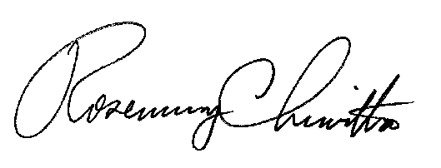
In Witness Whereof, The PENNSYLVANIA PUBLIC UTILITY COMMISSION has caused these presents to be signed and sealed, and duly attested by its Secretary at its office in the city of Harrisburg this 15th day, of July, 2021.

Secretary

