 | COMMONWEALTH OF PENNSYLVANIA  PENNSYLVANIA PUBLIC UTILITY COMMISSION  400 NORTH STREET, HARRISBURG, PA 17120 | IN REPLY PLEASE REFER TO OUR FILE
Date Served: July 21, 2021

SPIRIT MOVING COMPANY LLC C-2021-3026649
5040 LOUISE DRIVE STE 101
MECHANICSBURG PA 17055

RE: $500.00 Fine Payment

Dear Sir/Madam:

We are in receipt of Company check # 753 in the amount of $500.00 for the fine payment of Spirit Moving Company, LLC. at docket number C-2021-3026649. The Commission does not accept personal checks or checks drawn from a Corporate account. The $500.00 fine payment must be made in the form of a certified check or money order. Please remit this to the PUC as soon as possible. We apologize for the inconvenience.

Sincerely,

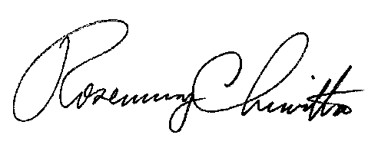
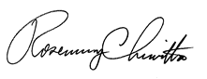

Rosemary Chiavetta
Secretary of the Commission

Enclosure

RC:ane

