 | COMMONWEALTH OF PENNSYLVANIA  PENNSYLVANIA PUBLIC UTILITY COMMISSION  400 North Street, Harrisburg, Pennsylvania 17120 | IN REPLY PLEASE REFER TO OUR FILE
Date Served: July 22, 2021

Via eService and Email ONLY.

TO ALL PARTIES OF RECORD:

RE: Public Utility Commission, Office of Consumer Advocate, and Office of Small Business Advocate
v.
Columbia Gas of Pennsylvania
Docket Number R-2021-3024349
Docket Number C-2021-3024643
Docket Number C-2021-3024762

On July 21, 2021, the Secretary served the Recommended Decision (both Proprietary and Public versions) of Administrative Law Judge Emily I. DeVoe at the above docket numbers.

However, it has been discovered that the incorrect exception period was issued in the Secretarial Letter accompanying the Recommended Decision (RD). The correct exception period is ten (10) days for Parties to file Exceptions to the RD, and seven (7) days for Parties to file Reply Exceptions.

Therefore, the Commission is re-serving the RD and setting the correct exception period in which the Parties may file Exceptions and Reply Exceptions. Parties will have until the close of business on August 2, 2021 (4:30 p.m. EST) to file Exceptions and until the close of business (4:30 p.m. EST) on August 9, 2021, to file Reply Exceptions.

Sincerely,
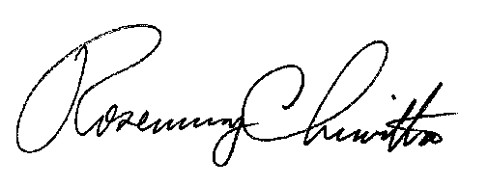

Rosemary Chiavetta
Secretary

Enclosure of Recommended Decision

cc: All Parties of Record
PUC Office of Special Assistants
Office of Administrative Law Judge

