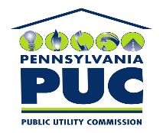 | COMMONWEALTH OF PENNSYLVANIA  PENNSYLVANIA PUBLIC UTILITY COMMISSION  400 NORTH STREET, HARRISBURG, PA 17120 | IN REPLY PLEASE REFER TO OUR FILE
July 23, 2021

U-2021-3026722

MICHAEL J SHAFER ATTORNEY
PPL SERVICES CORP
2 N 9TH ST
GENTW3
ALLENTOWN, PA 18101

Temporary Access Road Agreement dated May 20, 2021 between PPL Electric Utilities Corporation and Lehigh-Northampton Airport Authority located in Lehigh County relative with temporary rights needed for a maintenance project

To Whom It May Concern:

We enclose herewith the original and one (1) copy of certificate of filing issued by this Commission in accordance with Section 507 of the Public Utility Code, 66 Pa. C.S. §507.

You should serve the enclosed copy of this certificate upon the Lehigh-Northampton Airport Authority.

Very truly yours,


Rosemary Chiavetta
Secretary

nw
encls.
cert.mail

