 | COMMONWEALTH OF PENNSYLVANIA  PENNSYLVANIA PUBLIC UTILITY COMMISSION  400 NORTH STREET, HARRISBURG, PA 17120 | IN REPLY PLEASE REFER TO OUR FILE

July 26, 2021

A-6422600

A-2021-3025449

BRADEN SCOTT KENNEDY
T/A HERE-2-THERE TAXI
137 W 3RD STREET
OIL CITY PA 16301

Re: Application of Braden Scott Kennedy, t/a Here-2-There Taxi, 137 W 3rd Street, Oil City, Venango County, Pennsylvania 16301. (814) 673-5851

To Whom It May Concern:

The above application has been reviewed and it has been determined that all requirements have been met; Therefore,

YOU ARE ADVISED THAT:

(1) Your certificate of public convenience is enclosed.

(2) Your PUC Number which will be displayed on your vehicles is A-6422600

(3) You are granted authority to operate as follows:

Upon issuance of a Certificate of Public Convenience you are granted the right to operate as follows:
To transport, as a common carrier, by motor vehicle, persons in paratransit service, between points in the Counties of Allegheny, Beaver, Butler, Clarion, Crawford, Erie, Forest, Lawrence, Mercer, Venango, Warren, and Westmoreland.

If you have not previously submitted a copy of a current satisfactory safety rating from the U.S. Department of Transportation or another state with safety regulations comparable to Pennsylvania, you must demonstrate safety fitness by completing a Safety Fitness Review which will be scheduled by a PUC enforcement officer within 180 days of the date your certificate of public convenience is issued/entered. Failure to submit to the Safety Fitness Review will result in the cancellation of your certificate. An overview of the safety regulations for carriers of people, property, and household goods between points in Pennsylvania can be found on the PUC’s Website: www.puc.pa.gov/general/onlineforms/pdf/safety_fitness_compliance.pdf

You should become familiar with the requirements of 52 Pa. Code as applicable to the operation of a common carrier as authorized by this grant of authority. Any change in address of Braden Scott Kennedy, t/a Here-2-There Taxi must be reported to the Commission by filing a Change of Address Form. This form can be found on the Commission's website at: www.puc.pa.gov/general /onlineforms/pdf/MC_Address_Change.pdf. Failure to comply with all applicable requirements may subject the carrier to penalties, including fines, suspension of operating rights or cancellation of authority. Title 52 of the Pennsylvania Code may be accessed at www.pacode.com.

If you are dissatisfied with the resolution of this matter, you may, as set forth in 52 Pa. Code §5.44, file a petition with the Commission within twenty (20) days of the date of this Letter.

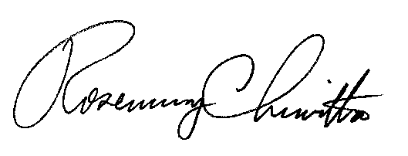
Very truly yours,

Rosemary Chiavetta
Secretary

Contact: Insurance (717-787-1227)
Safety (717-787-7598)

