PENNSYLVANIA
PUBLIC UTILITY COMMISSION

IN THE MATTER OF : A-8923980

Application for Household Goods in Use Authority, Move Solutions LLC t/a College Hunks Hauling Junk and Moving of Levittown, 4800 Boston Avenue, Trevose, Bucks County, PA 19053 To transport, as a common carrier, by motor vehicle, Household Goods in Use, between points in Pennsylvania. A-2021-3025467

EFFECTIVE: July 29, 2021

The Pennsylvania Public Utility Commission hereby certifies that after an investigation and/or hearing, it has, by its report and order made and entered, found and determined that the granting of the application is necessary or proper for the service, accommodation, convenience and safety of the public and hereby issues to the applicant this CERTIFICATE OF PUBLIC CONVENIENCE evidencing the Commission's approval to operate as a motor carrier.

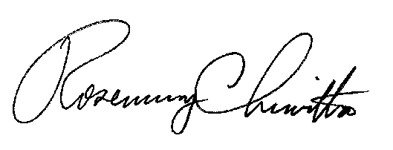
In Witness Whereof, The PENNSYLVANIA PUBLIC UTILITY COMMISSION has caused these presents to be signed and sealed, and duly attested by its Secretary at its office in the city of Harrisburg this 29th day, of July, 2021.

Secretary

