 | COMMONWEALTH OF PENNSYLVANIA  PENNSYLVANIA PUBLIC UTILITY COMMISSION  P.O. BOX 3265, HARRISBURG, PA 17105-3265 | IN REPLY PLEASE REFER TO OUR FILE

C-2021-3027402

Date of Service: August 2, 2021

WESTERN PENNSYLVANIA AMISH HOSPITALITY COMPANY
T/A SIMPLE LIFE TOURS
3459 STATE ROUTE 956
NEW CASTLE, PA 16105

PENNSYLVANIA PUBLIC UTILITY COMMISSION
BUREAU OF INVESTIGATON & ENFORCEMENT
v.
WESTERN PENNSYLVANIA AMISH HOSPITALITY COMPANY
T/A SIMPLE LIFE TOURS

Dear Sir/Madam:

Please be advised that the attached complaint has been filed against you by the Bureau of Investigation & Enforcement.

Detailed instructions on how to proceed are contained in the NOTICE section, and you are advised to read everything carefully or consult with your attorney.

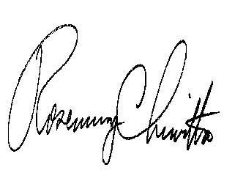
Very truly yours,

Rosemary Chiavetta
Secretary

Attachments
NW

