 | COMMONWEALTH OF PENNSYLVANIA  PENNSYLVANIA PUBLIC UTILITY COMMISSION  P.O. BOX 3265, HARRISBURG, PA 17105-3265 | IN REPLY PLEASE REFER TO OUR FILE

C-2021-3027324
Date of Service: August 3, 2021

SACKO SERVICES LLC
2320 NORTH 12TH STREET
PHILADELPHIA, PA 19133

PENNSYLVANIA PUBLIC UTILITY COMMISSION
BUREAU OF INVESTIGATON & ENFORCEMENT
v.
SACKO SERVICES LLC

Dear Sir/Madam:

Please be advised that the attached complaint has been filed against you by the Bureau of Investigation & Enforcement.

Detailed instructions on how to proceed are contained in the NOTICE section, and you are advised to read everything carefully or consult with your attorney.

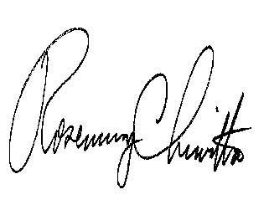
Very truly yours,

Rosemary Chiavetta
Secretary

Attachments

NW

