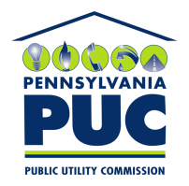 | COMMONWEALTH OF PENNSYLVANIA  PENNSYLVANIA PUBLIC UTILITY COMMISSION  400 NORTH STREET, KEYSTONE BUILDING, SECOND FLOOR  HARRISBURG, PENNSYLVANIA 17120 | IN REPLY PLEASE REFER TO OUR FILE

August 2, 2021

Via Certified Mail

Melissa Cole
Eligo Energy LLC
201 West Lake Street Suite 151
Chicago IL 60606

RE: Bond Continuation Certificate and Rider
Eligo Energy PA LLC
A-2014-2433211

Dear Ms. Cole:

Please find under cover of this letter the updated financial instruments filed with the Commission on behalf of Eligo Energy PA LLC because they are copies and not acceptable.

The Commission requires a supplier to file an original bond, letter of credit, continuation certificate, amendment, or other financial instrument as part of a supplier’s licensing requirements under Section 2809(c) of the Pennsylvania Public Utility Code.

The enclosed financial instruments do not have a "wet ink" original signature or raised seal for the surety company. Please file the corrected, originally signed and sealed security instruments with my office within 30 days of the date of this letter, preferably by overnight delivery. If you are unable to meet this deadline due to the ongoing pandemic emergency of COVID-19, please email Secretary Rosemary Chiavetta at rchiavetta@pa.gov.

Sincerely,

Rosemary Chiavetta
Secretary of the Commission

RC: alw
Enclosures

