 | COMMONWEALTH OF PENNSYLVANIA  PENNSYLVANIA PUBLIC UTILITY COMMISSION  P.O. BOX 3265, HARRISBURG, PA 17105-3265 | IN REPLY PLEASE REFER TO OUR FILE

C-2021-3027235
Date of Service: August 4, 2021

MILLENNIUM MOVING CO., INC.
754 TWINING WAY
COLLEGEVILLE, PA 19426

PENNSYLVANIA PUBLIC UTILITY COMMISSION
BUREAU OF INVESTIGATON & ENFORCEMENT
v.
MILLENNIUM MOVING CO., INC.

Dear Sir/Madam:

Please be advised that the attached complaint has been filed against you by the Bureau of Investigation & Enforcement.

Detailed instructions on how to proceed are contained in the NOTICE section, and you are advised to read everything carefully or consult with your attorney.

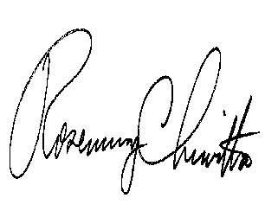
Very truly yours,

Rosemary Chiavetta
Secretary

Attachments

NW

