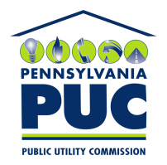 | COMMONWEALTH OF PENNSYLVANIA  PENNSYLVANIA PUBLIC UTILITY COMMISSION  400 NORTH STREET, KEYSTONE BUILDING, SECOND FLOOR  HARRISBURG, PENNSYLVANIA 17120 | IN REPLY PLEASE REFER TO OUR FILE

August 20, 2021

Via Certified Mail

KEVIN CAREY
AOBA ALLIANCE INC.
1025 CONNECTICUT AVENUE NW, SUITE 1005
WASHINGTON DC 20036

RE: Continuation Certificate
AOBA Alliance Inc
A-2010-2197104

Dear Sir/Madam:

Please find under cover of this letter the financial instrument filed with the Commission on behalf of AOBA Alliance Inc because it is not acceptable.

The Commission requires a supplier to file an original bond, letter of credit, continuation certificate, amendment, or other financial instrument as part of a supplier’s licensing requirements under Section 2809(c) of the Pennsylvania Public Utility Code.

The enclosed financial instrument does not have signature for the surety company

Please file the originally signed and sealed security instrument with my office within 20 days of the date of this letter, preferably by overnight delivery.

Sincerely,

Rosemary Chiavetta
Secretary of the Commission

RC:jbs

