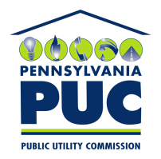 | COMMONWEALTH OF PENNSYLVANIA  PENNSYLVANIA PUBLIC UTILITY COMMISSION  400 North Street, Keystone Building, Second Floor  Harrisburg, Pennsylvania 17120 | IN REPLY PLEASE REFER TO OUR FILE

April 28, 2021

Via Certified Mail

Energy Paradigm LLC
6533 Virginia Square
Arlington TX 76017

RE: Bond Continuation Certificate
Energy Paradigm LLC
A-2017-2585765

Dear Sir/Madam:

Please find under cover of this letter the updated financial instrument you filed with the Commission on behalf of Energy Paradigm LLC because it is not acceptable.

The Commission requires a supplier to file an original bond, letter of credit, continuation certificate, amendment, or other financial instrument as part of a supplier’s licensing requirements under Section 2809(c) of the Pennsylvania Public Utility Code.

The Bond Continuation you filed lists the effective date as October 25, 2020, and the date of expiry as October 25, 2021, which is identical to the Continuation Certificate already on file with the Commission. Therefore, please file a corrected, original financial instrument with my office within 30 days of the date of this letter, preferably by overnight delivery. If you are unable to meet this deadline due to the ongoing pandemic emergency of COVID-19, please email Secretary Rosemary Chiavetta at rchiavetta@pa.gov.

Sincerely,

Rosemary Chiavetta
Secretary of the Commission

RC:alw
Enclosures

