COMMONWEALTH OF PENNSYLVANIA
PENNSYLVANIA PUBLIC UTILITY COMMISSION
400 NORTH STREET, HARRISBURG PA 17120
IN REPLY PLEASE
REFER TO OUR FILE
Secretary
717-772-7777
August 27, 2021
A-2021-3028191
JENNEDY S. JOHNSON, ESQUIRE
PECO ENERGY COMPANY
2301 MARKET STREET, S23-1
PHILADELPHIA, PA 19103
jennedy.johnson@exeloncorp.com

Dear Ms. Johnson:

Receipt is acknowledged of the Letter of Notification of PECO Energy Company, which has been captioned and docketed to the above number.

This matter will receive the attention of the Commission and you will be advised of any further necessary procedure.

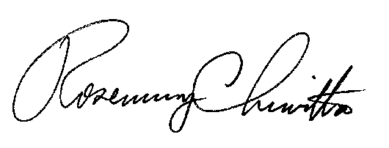
Sincerely,

Rosemary Chiavetta
Secretary

RC:JBS

