 | COMMONWEALTH OF PENNSYLVANIA  PENNSYLVANIA PUBLIC UTILITY COMMISSION  P.O. BOX 3265, HARRISBURG, PA 17105-3265 | IN REPLY PLEASE REFER TO OUR FILE

C-2021-3025340

Date of Service: August 30, 2021

DAVID HYDO
T/A BEDFORD TRANSPORTATION CO II
285 RIVERFRONT DRIVE
BEDFORD, PA 15522

PENNSYLVANIA PUBLIC UTILITY COMMISSION
BUREAU OF INVESTIGATON & ENFORCEMENT
v.
DAVID HYDO T/A BEDFORD TRANSPORTATION CO II

Dear Sir/Madam:

Please be advised that the attached complaint has been filed against you by the Bureau of Investigation & Enforcement.

Detailed instructions on how to proceed are contained in the NOTICE section, and you are advised to read everything carefully or consult with your attorney.

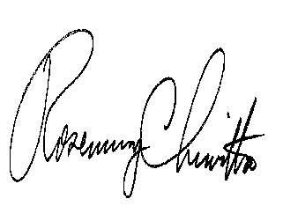
Very truly yours,

Rosemary Chiavetta
Secretary

Attachments

NW

