 | COMMONWEALTH OF PENNSYLVANIA  PENNSYLVANIA PUBLIC UTILITY COMMISSION  400 NORTH STREET, HARRISBURG, PA 17120 | IN REPLY PLEASE REFER TO OUR FILE

September 2, 2021

A-2016-2534040
A-00117920

JAMES & DEBRA AMENT
T/A WE-HAUL MOVING
1866 AUBURN STREET
BETHLEHEM PA 18105

Reinstatement of Certificate of Public Convenience, James & Debra Ament t/a We-Haul Moving

To Whom It May Concern:

Please be advised that the records of the Commission show that James & Debra Ament t/a We-Haul Moving has complied with the Form E, Form H and Tariff filing, in accordance with the Commission Opinion and Order entered June 17, 2021.

Therefore, the Certificate of Public Convenience at A-00117920 has been reinstated.

A copy of this Secretarial Letter which reinstates the Certificate of Public Convenience issued to James & Debra Ament t/a We-Haul Moving, at A-00117920, shall be served on:

The Pennsylvania Department of Transportation
Attn: Craig Johnson
1101 South Front Street - Second Floor
Harrisburg, PA 17104
and
The Department of Revenue
Bureau of Audit Programs
Sales and Use Taxes
Tenth Floor, Strawberry Square
Harrisburg, PA 17128-1061

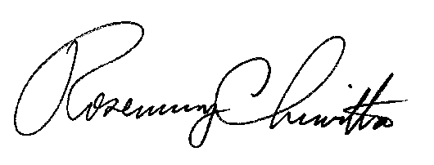
Very truly yours,

Rosemary Chiavetta,
Secretary

Cc: Secretary’s Bureau – File
Bureau of Investigation and Enforcement - Safety Office

