Via electronic service only due to Emergency Order at M-2020-3019262

BEFORE THE
PENNSYLVANIA PUBLIC UTILITY COMMISSION

James Elliott :
:
v. : C-2021-3024007
:
Pennsylvania Electric Company :

INTERIM ORDER
CLOSING THE RECORD

AND NOW, the transcript of the May 19, 2021, hearing in this case having been filed with the Commission’s Secretary’s Bureau in Harrisburg on August 24, 2021; and no further hearings in this matter are to be scheduled or held,

THEREFORE,

IT IS ORDERED:

- That the record at Docket No. C-2021-3024007 is closed.

2. That the Initial Decision in this case shall be prepared and issued.

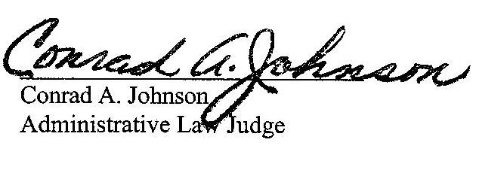
Dated: September 3, 2021

C-2021-3024007 - JAMES E. ELLIOTT JR v. PENNSYLVANIA ELECTRIC COMPANY
Revised 3/18/21
JAMES E. ELLIOTT JR.
263 HOUSE15 4TH ST
P.O. BOX 133
LUCERNE MINES PA 15748
724.599.7810
msstephanie5690@gmail.com
“Via e-mail only due to
Emergency Order at M-2020-3019262”
MARGARET MORRIS ESQUIRE
REGER RIZZO & DARNALL
CIRA CENTRE 13TH FL
2929 ARCH STREET
PHILADELPHIA PA 19104
215.495.6524
mmorris@regerlaw.com
Accepts eService

