 |  | COMMONWEALTH OF PENNSYLVANIA  PENNSYLVANIA PUBLIC UTILITY COMMISSION  400 NORTH STREET, KEYSTONE BUILDING SECOND FLOOR  HARRISBURG, PA 17120 |  | IN REPLY PLEASE REFER TO OUR FILE  Phone: 717-772-7777
Formal Complaint Docket #: C-2021-3028511

Date Served: September 15, 2021

Via e-mail only due to Emergency Order at M-2020-3019262

MICHAEL W. HASSELL, ESQUIRE
POST & SCHELL, P.C.
17 NORTH SECOND STREET, 12TH FLOOR
HARRISBURG, PA 17101-1601
Email: mhassell@postschell.com

RE: PA PUC vs AQUA PENNSYLVANIA WASTEWATER INC
Rate Case Docket #: R-2021-3027386

Dear Sir,

A Formal Complaint has been filed against Aqua Pennsylvania Wastewater, Inc., in the above-captioned matter before the Pennsylvania Public Utility Commission by the Office of Small Business Advocate.

This true and correct copy of the complaint has been filed of record with the Pennsylvania Public Utility Commission. Both the Pennsylvania Public Utility Code, 66 Pa. C.S. and the Commission’s regulations at 52 Pa. Code Section 1.53, requires the Commission to serve on each party named in a Formal Complaint a copy of the complaint.

Within ten (10) days from the above date of service, you may either satisfy or answer this complaint in accordance with the provisions of 52 Pa Code, §5.61(d).

When filing your answer to the Formal Complaint, please reference the “Formal Complaint Docket Number” located in the upper-right hand corner of this Notice.

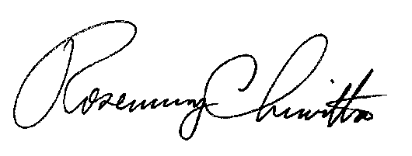
Very Truly Yours,

Rosemary Chiavetta
Secretary

RC:AEL
(SEAL)

VIA EMAIL DUE TO EMERGENCY ORDER AT M-2020-3019262

