October 8, 2021
Docket No. A-2021-3029000

LAST MINUTE MOVING LLC
29 TWIN OAK DR
LEVITTOWN PA 19056

RE: Application of Last Minute Moving, LLC, 924 Woodbourne Rd., Levittown, Bucks County, PA 19057. 215-936-9249

To Whom It May Concern:

On October 6, 2021, the applicant of LAST MINUTE MOVING, LLC, was accepted by the Commission; however, multiple issues must be addressed before publication to the Pennsylvania Bulletin may proceed. Please review page three of this correspondence for additional information and respond appropriately.

Please forward the information to the Secretary of the Commission within ten (10) working days from the date of this letter. Currently, the only acceptable means of filing your response is through the Commission’s e-file system. Information is available at the following link to efile: https://www.puc.state.pa.us/efiling/default

Your answers should be verified per 52 Pa Code § 1.36. Accordingly, you must provide the following statement with your responses:

I, ________________, hereby state that the facts above set forth are true and correct to the best of my knowledge, information and belief, and that I expect to be able to prove the same at a hearing held in this matter. I understand that the statements herein are made subject to the penalties of 18 Pa.C.S. § 4904 (relating to unsworn falsification to authorities).

The blank should be filled in with the name of the appropriate company representative, and the signature of that representative should follow the statement.

Please submit your response to the address cited in this letter’s header. Faxes, emails, and other forms of filing are unacceptable.

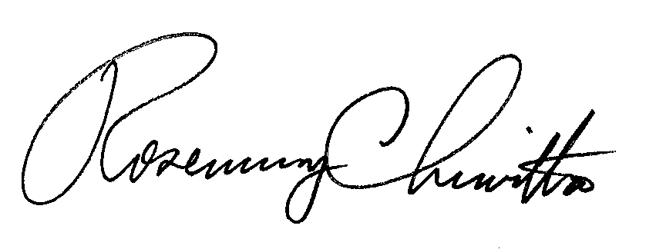
Sincerely,

Rosemary Chiavetta, Secretary

Enclosure

cc: Josh Kwiatkowski
Docket No. A-2021-3029000
LAST MINUTE MOVING, LLC
Data Request

- In order for this Commission to accept an application for further processing, the proposed service area must be fully bound, and easily discernible. This may be achieved by the use of municipal boundaries, roads, railroads, or natural boundaries such as rivers or streams, etc. YOU SHOULD ONLY SPECIFY AREAS FROM WHICH YOU WISH TO ORIGINATE SERVICE.

Examples:
i. from points in the counties of X, Y, and Z, to points in Pennsylvania, and return

ii. from points in the counties of X, Y, and Z, to points in counties of A, B, and C, and return

Language such as, “Bucks County and surrounding [areas]” is insufficiently vague. Please revise your request to reflect the guidance provided above

