 | COMMONWEALTH OF PENNSYLVANIA  PENNSYLVANIA PUBLIC UTILITY COMMISSION | IN REPLY PLEASE REFER TO OUR FILE
October 12, 2021
R-2021-3024750 et al.
Pennsylvania Public Utility Commission et al.

v.

Duquesne Light Company

TO ALL PARTIES:

Enclosed is a copy of the Recommended Decision of the Office of Administrative Law Judge.

If you do not agree with any part of this decision, you may send written comments (called Exceptions) to the Commission. Your signed Exceptions to the decision, if any, must be: 1) filed with the Secretary of the Commission, and 2) within ten (10) days of the date of this letter.

In accordance with the requirements of the Commission’s Emergency Order at Docket Number M-2020-3019262 under the pandemic emergency, and since the Commission has no access to mail delivery, Exceptions must be efiled with the Secretary of the Commission by opening an efiling account through the Commission’s website and accepting eservice at http://www.puc.state.pa.us/efiling/default.aspx. If your filing contains confidential material, you may email your exceptions to rchiavetta@pa.gov .

In addition to filing with the Secretary of the Commission, a courtesy copy of your Exceptions must be emailed to the Commission’s Office of Special Assistants (OSA) at ra-OSA@pa.gov. Your filing should not be larger than 10mb.

Replies to Exceptions, if any, must be efiled with the Secretary of the Commission and served on each party of record and the Commission’s Office of Special Assistants in the manner described above. They are due within seven (7) days of the date when Exceptions are due.

It is your responsibility to serve all the parties with your Exceptions and Replies to Exceptions. Failure to do so may render your filing unacceptable. A certificate of service (see format in 52 Pa. Code §1.58) shall be attached to the filed Exceptions or Replies to Exceptions.

Exceptions and Replies to Exceptions shall follow 52 Pa. Code §§5.533 and 5.535 particularly the 40-page limit for Exceptions and the 25-page limit for Replies to Exceptions. Exceptions should clearly be labeled as "EXCEPTIONS OF (name of party) - (protestant, complainant, staff, etc.)". Any reference to specific sections of the Administrative Law Judge’s Recommended Decision shall include the page number(s) of the cited section of the decision.

If no Exceptions are received, the decision of the Administrative Law Judge could become final without further Commission action. You will receive written notification if this occurs. However, even if no exceptions are received, the Commission may review and change the decision pursuant to Section 332(h) of the Public Utility Code, 66 Pa. C.S. § 332(h) and 52 Pa. Code Section 5.536.

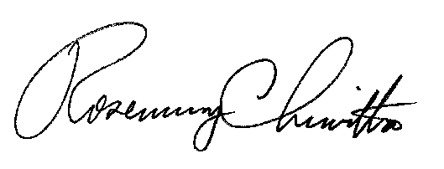
Sincerely,

Rosemary Chiavetta
Secretary
Decision attached

