PENNSYLVANIA
PUBLIC UTILITY COMMISSION
Harrisburg, PA 17105-3265

Application of Aqua Pennsylvania Wastewater, : A-2021-3024267
Inc., (APW), under Sections 1102 and 1329 of :
the Pennsylvania Public Utility Code, 66 Pa C.S. :
§§ 1102(a) and 1329 (relating to enumeration of :
acts requiring certificate and valuation of :
acquired water and wastewater systems), for :
approval of: (1) the transfer, by sale, of :
substantially all of the wastewater system assets, :
properties and rights of Lower Makefield Township :
(LMT) related to its wastewater collection and :
conveyance system; (2) the right of APW to begin :
to offer or furnish wastewater service to the public :
in Lower Makefield Township, Bucks County, :
Pennsylvania; and (3) the use for ratemaking :
purposes of the lesser fair market value or the :
negotiated purchase price of the LMT assets related :
to its wastewater collection and conveyance system. :

FINAL ORDER

In accordance with the provisions of Section 332(h) of the Public Utility Code, 66 Pa. C.S. §332(h), the decision of Administrative Law Judge Jeffrey A. Watson dated September 17, 2021, has become final without further Commission action:

THEREFORE,

IT IS ORDERED:

1. That the preliminary objection of Aqua Pennsylvania Wastewater Inc., to dismiss the protest of the Peter A. Lachance at Docket No. A-2021-3024267, is sustained.

2. That the protest of Peter A. Lachance at Docket No. A-2021-3024267 is dismissed.

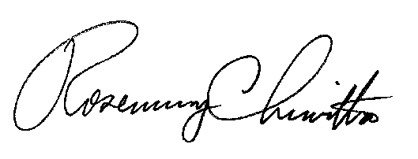
BY THE COMMISSION,

Rosemary Chiavetta
Secretary

(SEAL)

ORDER ENTERED: October 22, 2021

