November 8, 2021
A-8924615
A- 2021-3029000

LAST MINUTE MOVING LLC
29 TWIN OAK DR
LEVITTOWN PA 19056

RE: Application of Last Minute Moving, LLC, 924 Woodbourne Rd., Levittown, Bucks County, PA 19057. 215-936-9249

To Whom It May Concern:

The purpose of this Letter is to advise you that your Application, Docket No. A- 2021-3029000 has been DENIED by the Pennsylvania Public Utility Commission (Commission). The Commission has determined that a Certificate of Public Convenience WILL NOT BE GRANTED for the following reason(s):

- Failure to fully comply with a Commission data request – On October 8, 2021, the applicant was issued a 10 day data request to supply the Commission with information which was deemed essential to further process the application. To date, more than 30 days later, the applicant has failed to submit a response.

For these reasons the application is DISMISSED and DENIED

APPEAL RIGHTS

ALL Parties to proceedings pending before the Commission must open and use an e-filing account through the Commission’s website, OR you may submit your filing by overnight delivery. If a filing contains confidential or proprietary material, the filing is required to be submitted by overnight delivery.

If you disagree with this determination, you may send a Petition for Reconsideration to: Secretary, Pennsylvania Public Utility Commission, 400 North Street, Harrisburg, PA 17120. Such a Petition is a written statement asking the Commission to change its determination.

The Petition must be filed with the Commission within twenty (20) days of the date of this letter. If no timely request for reconsideration is made, this action will be deemed to be the final action of the Commission.

The Petition MUST include: (1) a written statement (divided into numbered paragraphs) outlining the reasons for the request, (2) the case docket number(s) (they are provided for you at the top right hand corner of this letter), (3) the name of the person on whose behalf the petition is made, (4) copies of relevant documentation, and (5) a verification with original signature. See 52 Pa. Code §§-1.31 and 5.44.

Below is a sample Verification:

VERIFICATION

I, (YOUR NAME GOES HERE), hereby state that the facts above set forth are true and correct (or are true and correct to the best of my knowledge, information and belief) and that I expect to be able to prove the same at a hearing held in this matter. I understand that the statements herein are made subject to the penalties of 18 Pa.C.S. § 4904 (relating to unsworn falsification to authorities).
(Applicant is not now engaged in intrastate transportation of property or passengers for compensation in this Commonwealth except as authorized by the Pennsylvania Public Utility Commission certificate or permit, and will not engage in the transportation for which approval is herein sought, unless and until the transportation is authorized by your Honorable Commission.)

(SIGN AND DATE)

CONCLUSION

If you believe that you have received this letter in error, please contact the Compliance Office of the Motor Carrier Services in the Bureau of Technical Utility Services at 717-787- 3834 within ten (10) days of the date of this letter.

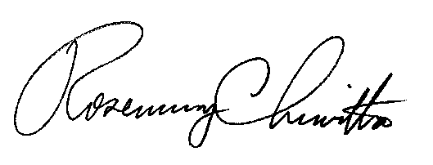
Very truly yours,

Rosemary Chiavetta
Secretary

