COMMONWEALTH OF PENNSYLVANIA
PENNSYLVANIA PUBLIC UTILITY COMMISSION
COMMONWEALTH KEYSTONE BUILDING
400 NORTH STREET
HARRISBURG, PENNSYLVANIA 17120

November 18, 2021
Mr. Michael German
President & Chief Executive Officer
Corning Natural Gas Corporation
330 West William Street
Corning, NY 14830
mgerman@corninggas.com

Re: Management Efficiency Investigation (MEI), D-2020-3022546 and D-2020-3022547

Dear Mr. German:

The Commission appreciates the cooperation extended by the officers and employees of Pike County Light and Power Company and Leatherstocking Gas Company LLC (collectively referred to as companies) to our audit staff during the recent Management Efficiency Investigation. We seek the companies’ further cooperation in implementing the recommendations cited in the MEI audit report.

At its Public Meeting of November 18, 2021, the Commission acknowledged receipt of the companies’ Implementation Plan submitted on October 22, 2021 and released it to the public, along with the Audit Staff’s MEI report. The Commission notes that companies’ Implementation Plan indicates acceptance or partial acceptance of 25 recommendations and rejection of one recommendation. Receipt of the Implementation Plan does not constitute acceptance by the Commission of the actions already taken, those to be taken, or the explanations and analysis provided. The companies’ implementation actions, together with any explanations and cost/benefit analyses, may be reviewed by the Commission at a later date. This review would be made to determine if the company has effectively implemented the recommendations.

Accordingly, the Commission directs the companies to proceed with the October 22, 2021 Implementation Plan. The Commission’s direction to proceed with the Implementation Plan should not be construed as approval of the plan.

Sincerely,
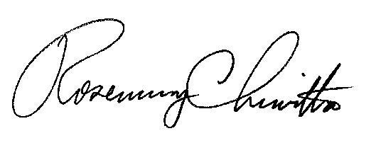

Rosemary Chiavetta
Secretary

Contact Person: John Clista
(717) 772-0317

