|  |  |  |
| --- | --- | --- |
|  | COMMONWEALTH OF PENNSYLVANIA  PENNSYLVANIA PUBLIC UTILITY COMMISSION  COMMONWEALTH KEYSTONE BUILDING  400 NORTH STREET, HARRISBURG, PA 17120  <http://www.puc.pa.gov> | **IN REPLY PLEASE REFER TO OUR FILE** |

**November 22, 2021**

**M-2021-3028299**

**A-8922122**

R + R VENDORS INC  
1936 5TH AVENUE  
PITTSBURGH PA 15219

Re: Cancellation of Certificate of Public Convenience

Docket No. A-2020-3020399

To Whom it May Concern:

On September 15, 2021, the Commission entered a Tentative Order, Docket No.

M-2021-3028299, which advised R + R Vendors, Inc. that it was not in compliance with the insurance requirements of 66 Pa.C.S. § 512. The Tentative Order advised R + R Vendors, Inc., that it must, within 30 days of publication of the Tentative Order, either have acceptable evidence of insurance filed with the Commission or cancel their authority or file comments to the Tentative Order. The Tentative Order advised R + R Vendors, Inc., that, if it failed to respond, its certificate of public convenience would be cancelled. The Tentative Order was served on R + R Vendors, Inc. and published in the *Pennsylvania Bulletin*.

R + R Vendors, Inc. failed to respond to the September 15, 2021 Tentative Order and remains in non-compliance with the insurance requirements of the Public Utility Code at 66 Pa.C.S. § 512.

**YOU ARE ADVISED:** That the certificate(s) issued at Docket No. R + R Vendors, Inc. be and is hereby ***cancelled***, and all rights, powers, and privileges granted thereby shall forthwith cease and terminate.

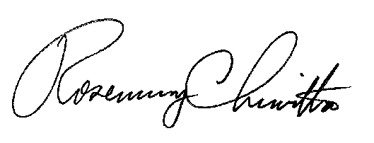 Sincerely,

# Rosemary Chiavetta

Secretary

cc: Secretary’s Bureau – File

Bureau of Investigation and Enforcement – Safety Division

Bureau of Administrative Services – Fiscal

PA Department of Transportation

PA Department of Revenue