 | COMMONWEALTH OF PENNSYLVANIA  PENNSYLVANIA PUBLIC UTILITY COMMISSION  400 North Street, HARRISBURG, PA 17120 | IN REPLY PLEASE REFER TO OUR FILE  M-2021-3028299  A-8922848

November 22, 2021

HART EXPRESS LLC
517 D STREET
CARLISLE PA 17013

Re: Cancellation of Certificate of Public Convenience A-8922848

To Whom it May Concern:

On September 15, 2021, the Commission entered a Tentative Order, Docket No.
M-2021-3028299, which advised Hart Express LLC that it was not in compliance with the insurance requirements of 66 Pa.C.S. § 512. The Tentative Order advised Hart Express LLC, that it must, within 30 days of publication of the Tentative Order, either have acceptable evidence of insurance filed with the Commission or cancel their authority or file comments to the Tentative Order. The Tentative Order advised Hart Express LLC, that, if it failed to respond, its certificate of public convenience would be cancelled. The Tentative Order was served on Hart Express LLC and published in the Pennsylvania Bulletin.

Hart Express LLC failed to respond to the September 15, 2021 Tentative Order and remains in non-compliance with the insurance requirements of the Public Utility Code at 66 Pa.C.S. § 512.

YOU ARE ADVISED: That the certificate(s) issued at Docket No. A-8922848 be and is hereby cancelled, and all rights, powers, and privileges granted thereby shall forthwith cease and terminate.

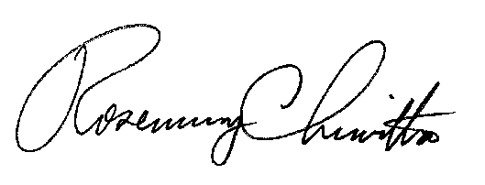
Sincerely,

Rosemary Chiavetta
Secretary

cc: Secretary’s Bureau – File
Bureau of Investigation and Enforcement – Safety Division
Bureau of Administrative Services – Fiscal
PA Department of Transportation
PA Department of Revenue

