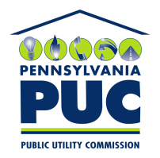 | COMMONWEALTH OF PENNSYLVANIA  PENNSYLVANIA PUBLIC UTILITY COMMISSION  400 NORTH STREET, KEYSTONE BUILDING, SECOND FLOOR  HARRISBURG, PENNSYLVANIA 17120 | IN REPLY PLEASE REFER TO OUR FILE
December 3, 2021

Via Certified Mail

Donald Medlin
Scarbrough Medlin & Associates
5700 Granite Parkway Suite 500
Plano TX 75024

RE: Bond Continuation Certificate
Verdigris Energy LLC
A-2012-2284040

Dear Mr. Medlin:

Please find under cover of this letter the financial instrument filed on behalf of Verdigris Energy LLC because it is not acceptable.

In all locations where the name of the Principal appears, please note that this must match exactly with the license issued by the Commission, including any trade or fictitious names that appear on the license. As the enclosed continuation lists “Vardigris Energy LLC” instead of “Verdigris Energy LLC”, it cannot be accepted.

Please file the original financial instrument with my office within 30 days of the date of this letter, preferably by overnight delivery. If you are unable to meet this deadline due to the ongoing pandemic emergency of COVID-19, please email Secretary Rosemary Chiavetta at rchiavetta@pa.gov.

Sincerely,

Rosemary Chiavetta
Secretary of the Commission

RC: alw
Enclosures

