BEFORE THE
PENNSYLVANIA PUBLIC UTILITY COMMISSION

Application of the Department of Transportation : A-2020-3020667
of the Commonwealth of Pennsylvania for approval :
to alter the crossings where State Route 3104 crosses, :
above grade, the tracks of CSX Transportation Inc. :
(DOT 584 825 U), Norfolk Southern Railway :
Company (DOT 507 455 K), and the Pittsburgh and :
Ohio Central Railroad Company (DOT Unknown) in :
the City of Pittsburgh, Stowe Township and McKees :
Rocks Borough, Allegheny County. :

INTERIM ORDER
CLOSING THE RECORD

AND NOW, the transcript of the September 30, 2021 hearing in this case having been filed with the Commission’s Secretary’s Bureau in Harrisburg on October 22, 2021; and the Parties’ Main Briefs having been filed on December 10, 2021; and no Reply Briefs having been filed within ten days of December 10, 2021; and no further hearings in this matter are to be scheduled or held,

THEREFORE,

IT IS ORDERED:

- That the record at Docket No. A-2020-3020667 is closed.

2. That the Recommended Decision in this case shall be prepared and issued.

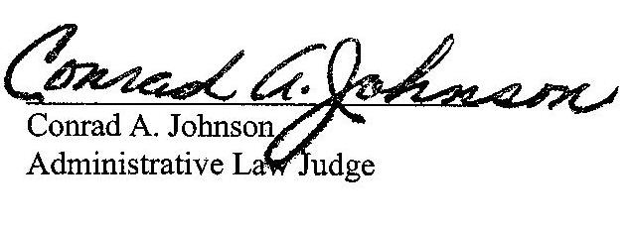
Dated: December 23, 2021

A-2020-3020667 –APPLICATION OF THE DEPARTMENT OF TRANSPORTATION OF THE COMMONWEALTH OF PENNSYLVANIA FOR APPROVAL TO ALTER THE CROSSINGS WHERE STATE ROUTE 3104 CROSSES, ABOVE GRADE, THE TRACKS OF CSX TRANSPORTATION INC. (DOT 584 825 U), NORFOLK SOUTHERN RAILWAY COMPANY (DOT 507 455 K), AND THE PITTSBURGH AND OHIO CENTRAL RAILROAD COMPANY (DOT UNKNOWN) IN THE CITY OFPITTSBURGH, STOWE TOWNSHIP AND MCKEES ROCKS BOROUGH, ALLEGHENY COUNTY

Revised 12/21/21

JENNIFER BROWN SWEENEY ESQUIRE
ERIC WHITE, ESQIRE
PENNDOT
OFFICEOF CHIEF COUNSEL
PO BOX 8212
HARRISBURG PA 17105-8212
717-787-3128
717-787-8212
jbrownswee@pa.gov
ewwhite@pa.gov
Accepts EService
KAYLA ROST COUNSEL
PA PUC BUREAU OF INVESTIGATION & ENFORCEMENT
400 NORTH STREET
HARRISBURG PA 17120
717-787-1888
karost@pa.gov
Accepts EService
MEGAN M TURNBULL ESQUIRE
DANIELLA GUARASCIO, ESQIRE
MCKEES ROCKS BOROUGH SOLICITOR
WEISS BURKARDT KRAMER LLC
445 FORT PITT BLVD STE 503
PITTSBURGH PA 15218
412-391-9890
mturnbull@wbklegal.com
dguarascio@wbklegal.com

BENJAMIN C. DUNLAP JR., ESQUIRE
NAUMAN SMITH SHISSLER & HALL
200 NORTH THIRD STREET
18TH FLOOR
HARRISBURG, PA 17101
717-236-3010
bdunlapjr@nssh.com
Accepts EService

