COMMONWEALTH OF PENNSYLVANIA
PENNSYLVANIA PUBLIC UTILITY COMMISSION
COMMONWEALTH KEYSTONE BUILDING
400 NORTH STREET
HARRISBURG, PENNSYLVANIA 17120
http://www.puc.pa.gov

January 3, 2022

A-00113582
M-2021-3028299

CONCORD LIMOUSINE INC
406 RIDGE PIKE
LAYFAYETTE HILL PA 19444

RE: Cancellation of Certificate of Public Convenience A-00113582

By Secretarial Letter dated November 22, 2021, the Commission cancelled the limousine authority of CONCORD LIMOUSINE INC at Case Docket No. M-2021-3028299 due to non-compliance with the insurance requirements of the Public Utility Code at 66 Pa.C.S. § 512.

This Commission has the power to rescind a Secretarial Letter in light of newly discovered evidence or a change of circumstances which justify reconsideration. Today, an administrative error was discovered. This error caused the limousine authority held at A-00113582 to be cancelled. This cancellation is now rescinded.

Therefore, the Certificate of Public Convenience at Docket No. A-00113582, will be reinstated.

Furthermore, this Commission is requesting the Pennsylvania Department of Transportation to lift any administrative holds on respondent’s vehicle registration.

Very truly yours,
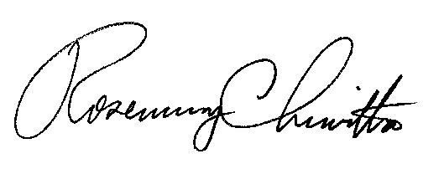

Rosemary Chiavetta
Secretary

Cc: Secretary’s Bureau – File
Bureau of Investigation & Enforcement
Bureau of Administrative Services – Fiscal
PA Department of Transportation
PA Department of Revenue

