 | COMMONWEALTH OF PENNSYLVANIA  PENNSYLVANIA PUBLIC UTILITY COMMISSION  COMMONWEALTH KEYSTONE BUILDING  400 NORTH STREET  HARRISBURG, PENNSYLVANIA 17120 | IN REPLY PLEASE REFER TO OUR FILE
January 5, 2022
U-2021-3029525
MICHAEL J SHAFER ATTORNEY
PPL SERVICES CORP
2 N 9TH ST
GENTW3
ALLENTOWN, PA 18101

Amendment of Easement Agreement dated October 13, 2021 between PPL Electric Utilities Corp and SEDA-COG Joint Rail Authority relative with the original easement agreement dated March 25, 1993.

To Whom It May Concern:

We enclose herewith the original certificate of filing issued by this Commission in accordance with Section 507 of the Public Utility Code, 66 Pa. C.S. §507.

Please acknowledge receipt of this certificate.

Very truly yours,
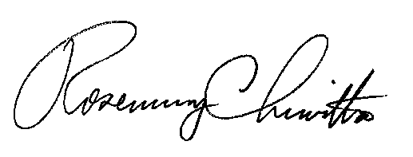

Rosemary Chiavetta
Secretary

NW
encls.
cert.mail

