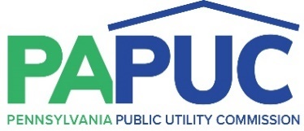 | COMMONWEALTH OF PENNSYLVANIA  PENNSYLVANIA PUBLIC UTILITY COMMISSION  COMMONWEALTH KEYSTONE BUILDING  400 NORTH STREET  HARRISBURG, PENNSYLVANIA 17120
January 10, 2022
R-2022-3030291
Utility Code: 110150

Michael Zimmerman
Duquesne Light Company.
411 Seventh Avenue
Mail Drop 15-7
Pittsburgh, PA 15219

Re: State Tax Adjustment Duquesne Light Company.

Dear Mr. Zimmerman:

On January 4, 2022, Duquesne Light Company filed Supplement No. 38 to Tariff Duquesne Light Company – Pa. P.U.C. No. 25 with an effective date of January 15, 2022, to adjust Duquesne Light Company’s STAS to two parts: Part 1 applies to the distribution component of customers’ bills, and Part 2 to all components of the bills. Herein, the Company proposes new tax surcharge rates of (0.0118%) for Part 1, and 0.00% for Part 2, to be effective January 15, 2022. The Commission hereby accepts these tariff changes, and we are therefore allowing the tariff to go into effect by operation of law. However, this notification shall not preclude this Commission from investigating the financial affairs of Duquesne Light Company and, in appropriate cases, ordering refunds or other remedies, which it deems proper.

If you have any questions in this matter, please contact Joel Greene, Bureau of Technical Utility Services, at joelgreene@pa.gov


Sincerely,

Rosemary Chiavetta
Secretary

cc: Marissa Boyle, TUS

