BEFORE THE
PENNSYLVANIA PUBLIC UTILITY COMMISSION

Conyngham Township :
:
v. : C-2021-3023624
:
Sanitary Sewer Authority :
of the Borough of Shickshinny :

FIFTH INTERIM ORDER
GRANTING RESPONDENT’S CONTINUANCE REQUEST

By Notice dated October 15, 2021, the Parties were informed that a Further Call-In Telephonic Hearing was scheduled before me for the captioned proceeding on Wednesday, January 19, 2022, at 10:00 a.m. By email on January 11, 2022, Sean W. Logsdon, Esquire, counsel for Respondent Sanitary Sewer Authority of the Borough of Shickshinny (SSABS), requested a continuance of the hearing. As the reason for the continuance request, Attorney Logsdon represented that he had a scheduling conflict due to an appearance in a court proceeding in Luzerne County. Attorney Logsdon further represented, that neither counsel for Complainant Conyngham Township nor counsel for the Commission’s Bureau of Investigation and Enforcement objected to the continuance request.

Although Attorney Logsdon’s email on behalf of SSABS requesting a hearing continuance does not conform to the requirements of a formal motion under Section 1.15(b) of the Commission’s regulations, waiver of this requirement is permitted. Under Section 1.2, 52 Pa.Code § 1.2, a presiding officer at any stage of an action or proceeding may waive a requirement of a rule when necessary or appropriate if waiver does not adversely affect a substantive right of a party. Such are the circumstances in this case. Therefore, Attorney Logsdon’s email dated January 11, 2022, is treated as SSABS’s motion for continuance of the scheduled hearing.

After due consideration, I find that the motion states good cause to warrant a
continuance. Thus, the motion will be granted in the ordering paragraphs below. A notice rescheduling the further call-in telephonic hearing for Wednesday, March 2, 2022, at 10:00 a.m., will be issued to the Parties.

The Parties are encouraged to talk with each other to resolve this matter or a
portion thereof. It is the Commission’s policy to encourage settlements. 52 Pa. Code §5.231.

THEREFORE,

IT IS ORDERED:

- That the motion of Respondent Sanitary Sewer Authority of the Borough of Shickshinny for a continuance of the Further Call-In Telephonic Hearing scheduled in this proceeding for Wednesday, January 19, 2022, is granted.
- That the Scheduling Staff of the Office of Administrative Law Judge shall reschedule the Further Call-In Telephonic Hearing in the case of Conyngham Township v. Sanitary Sewer Authority of the Borough of Shickshinny at Docket No. C-2021-3023624 for Wednesday, March 2, 2022, at 10:00 a.m. and so notify the Parties in writing.
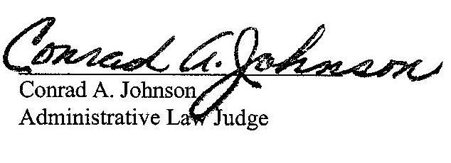

Date: January 13, 2022

C-2021-3023624 – CONYNGHAM TOWNSHIP V. SHICKSHINNY SANITARY SEWER AUTORITY OF THE BOROUGH OF SHICKSHINNY
VITO J DELUCA ESQUIRE
DELUCA LAW OFFICES
26 PIERCE STREET
KINGSTON PA 18704
570-288-8000
vjd@delucalawoffices.com
Accepts e-Service
Representing Conyngham Township

SEAN W LOGSDON ESQUIRE
85 DRASHER ROAD
DRUMS PA 18222
570-788-6647
sean@karpowichlaw.com
Accepts e-Service
Representing Sanitary Sewer Authority of The Borough of Shickshinny

SANITARY SEWER AUTHORITY OF THE BOROUGH OF SHICKSHINNY
1 MAIN RD
SHICKSHINNY PA 18655
shickauth@frontier.com

STEPHANIE M WIMER ESQUIRE
PENNSYLVANIA PUBLIC UTILITY COMMISSION
BUREAU OF INVESTIGATION & ENFORCEMENT
P.O BOX 3265
HARRISBURG, PA 17105
717-772-8839
stwimer@pa.gov
Accepts e-Service
Representing Bureau of Investigation & Enforcement

