 | COMMONWEALTH OF PENNSYLVANIA  PENNSYLVANIA PUBLIC UTILITY COMMISSION  COMMONWEALTH KEYSTONE BUILDING  400 NORTH STREET  HARRISBURG, PENNSYLVANIA 17120 | IN REPLY PLEASE REFER TO OUR FILE

C-2022-3027673

Date of Service: January 21, 2022

ALL MY SONS OF PITTSBURGH LLC
2400 OLD MILL ROAD
CARROLLTON TX 75007

PENNSYLVANIA PUBLIC UTILITY COMMISSION
BUREAU OF INVESTIGATON & ENFORCEMENT
v.
ALL MY SONS OF PITTSBURGH LLC

Dear Sir/Madam:

Please be advised that the attached complaint has been filed against you by the Bureau of Investigation & Enforcement.

Detailed instructions on how to proceed are contained in the NOTICE section, and you are advised to read everything carefully or consult with your attorney.

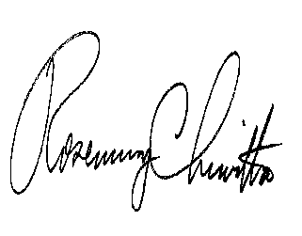
Very truly yours,

Rosemary Chiavetta
Secretary

Attachments

NW

