BEFORE THE
PENNSYLVANIA PUBLIC UTILITY COMMISSION

PENNSYLVANIA PUBLIC UTILITY COMMISSION | :
BUREAU OF INVESTIGATION AND ENFORCEMENT | :
 | :
v. | :
 | : | DOCKET NO. C-2022-3021696
 | :
KELLEHER TRUCKING LLC | :
288 LOCUST ROAD | :
BADEN PA 15005 | :
COMPLAINT

The Pennsylvania Public Utility Commission (Commission) is a duly constituted agency of the Commonwealth of Pennsylvania empowered to regulate public utilities within the Commonwealth. The Commission has delegated its authority to initiate proceedings which are prosecutory in nature to the Bureau of Investigation and Enforcement and other bureaus with enforcement responsibilities. Pursuant to that delegated authority and Section 701 of the Public Utility Code, the Bureau of Investigation and Enforcement hereby represents as follows:

- That Kelleher Trucking, LLC, Respondent, maintains a principal place of business at 288 Locust Road, Baden, Pennsylvania, 15005.

- That Respondent was issued a certificate of public convenience by this Commission authorizing transportation of property for compensation on September 1, 2020, at PUC utility code no. 8923286.

- That Respondent, by Commission secretarial letter dated July 16, 2020, was advised that failure to comply with all applicable requirements of the Commission may subject the carrier to penalties, including fines, suspension of operating rights, or cancellation of authority. This letter advised Respondent that a satisfactory safety fitness rating must be achieved in order to maintain a certificate of public convenience to operate as a common carrier of property.

- That PUC Enforcement Officer David Gill spoke with owner Donald T. Marshall III in early March 2021 and instructed him to email the required documents to obtain the satisfactory safety fitness rating. The documents were never received by Officer Gill despite repeated attempts via phone and email throughout October 2021.
- That Respondent, by failing to achieve a satisfactory evaluation on a safety fitness review, violated 66 Pa. C.S. §501(c) and, for failure to maintain adequate, efficient and safe service and facilities, violated 66 Pa. C.S. §1501.

WHEREFORE, the Bureau of Transportation Investigation and Enforcement hereby requests that the Commission revoke the certificate of public convenience issued Kelleher Trucking LLC PUC utility code no. 8923286.

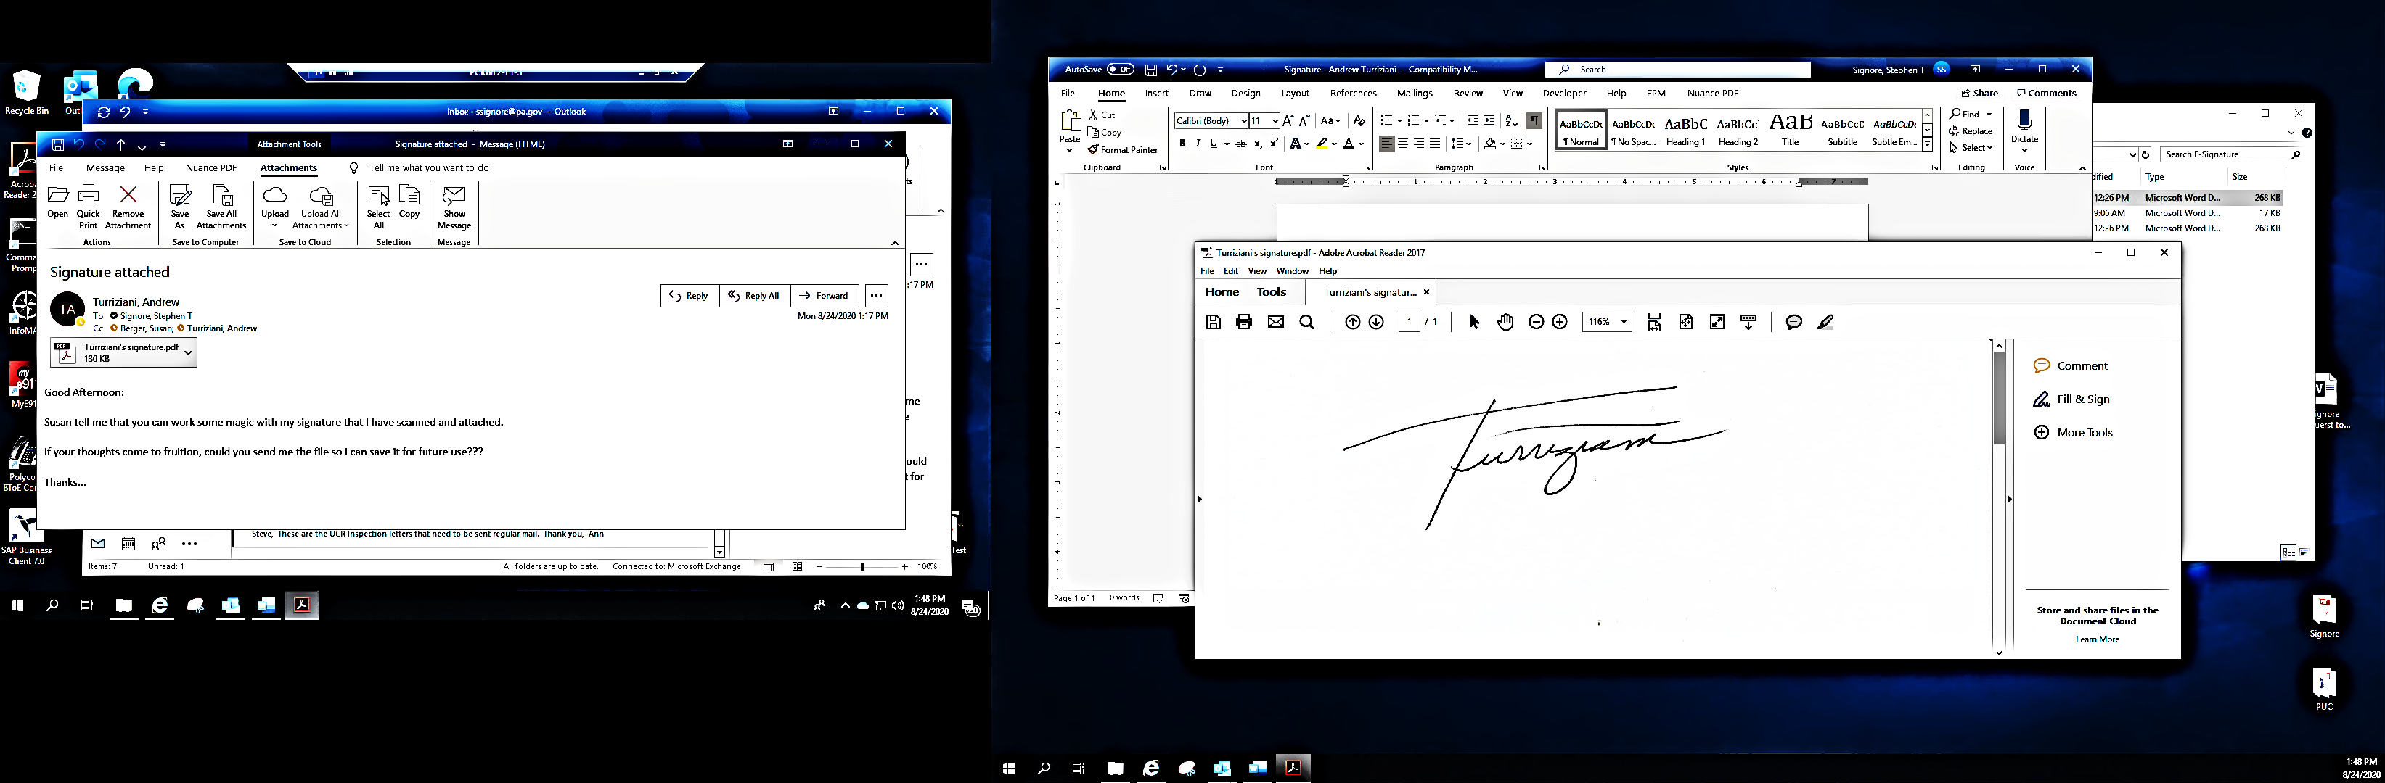
Respectfully submitted,

Andrew Turriziani, Chief
Motor Carrier Enforcement
Bureau of Investigation and Enforcement
400 North Street
Harrisburg, PA 17120

VERIFICATION

I, Andrew Turriziani, hereby state that the facts above set forth are true and correct to the best of my knowledge, information and belief and that I expect that the Bureau will be able to prove same at any hearing held in this matter. I understand that the statements herein are made subject to the penalties of 18 Pa. C.S. §4904 relating to unsworn falsification to authorities.

Date: January 11, 2022 Andrew Turriziani, Chief
Motor Carrier Enforcement
Bureau of Investigation and Enforcement

NOTICE

- You must file an Answer within twenty (20) days of the date of service of this Complaint. The date of service is the mailing date as indicated at the top of the Secretarial Cover Letter for this Complaint and Notice, 52 Pa. Code §1.56(a). An Answer is a written explanation of circumstances wished to be considered in determining the outcome. The Answer shall raise all factual and legal arguments that you wish to claim in your defense and must include the reference number of this Complaint. Your Answer must be verified, and the original shall be mailed to:

Rosemary Chiavetta, Secretary
Pennsylvania Public Utility Commission
400 North Street, 2nd Floor
Harrisburg, Pennsylvania 17120

Or you may eFile your Answer using the Commission’s website at www.puc.pa.gov. The link to eFiling is located under the Filing & Resources tab on the homepage. If your Answer is 250 pages or less, you are not required to file a paper copy. If your Answer exceeds 250 pages, you must file a paper copy with the Secretary’s Bureau.

Additionally, a copy should either be mailed to:

Michael L. Swindler, Deputy Chief Prosecutor
Bureau of Investigation and Enforcement
Pennsylvania Public Utility Commission
400 North Street
Harrisburg, Pennsylvania 17120

Or, e-mailed to Mr. Swindler at: RA-PCCmplntResp@pa.gov

- If you fail to answer this complaint within twenty (20) days, the Bureau of Investigation and Enforcement will request that the Commission issue a Secretarial Letter imposing a penalty. The penalty could include a fine, the suspension or revocation of your certificate of public convenience or other remedy.

- If you file an Answer, which admits or fails to deny the allegations of the Complaint, the Bureau of Investigation and Enforcement will request that the Commission issue a Secretarial Letter imposing a penalty.

- If you file an Answer which contests the Complaint, the matter will be assigned to an Administrative Law Judge for hearing and decision. The judge is not bound by the optional fine set forth above.

- Alternative formats of this material are available for persons with disabilities by contacting the Commission’s ADA Coordinator at 717-787-8714.

