BEFORE THE
PENNSYLVANIA PUBLIC UTILITY COMMISSION

PENNSYLVANIA PUBLIC UTILITY COMMISSION | :
BUREAU OF INVESTIGATION AND ENFORCEMENT | :
 | :
v. | :
 | : | DOCKET NO. C-2022-3025749
VICS TOWING LLC | :
7207 LAWNDALE AVE | :
PHILADELPHIA, PA 19111 | :
COMPLAINT

The Pennsylvania Public Utility Commission (Commission) is a duly constituted agency of the Commonwealth of Pennsylvania empowered to regulate public utilities within the Commonwealth. The Commission has delegated its authority to initiate proceedings which are prosecutory in nature to the Bureau of Investigation and Enforcement and other bureaus with enforcement responsibilities. Pursuant to that delegated authority and Section 701 of the Public Utility Code, the Bureau of Investigation and Enforcement hereby represents as follows:

- That Vic’s Towing LLC, Respondent, maintains a principal place of business at 7207 Lawndale Avenue, Philadelphia, Pennsylvania 19111.

- That Respondent was issued a certificate of public convenience by this Commission authorizing transportation of property goods for compensation on May 4, 2021, at PUC utility code no. 8923965.

- That Respondent, by Commission Secretarial letter dated April 29, 2021,
was advised, “If you have not previously submitted a copy of a current satisfactory safety rating from the U.S. Department of Transportation or another state with safety regulations comparable to Pennsylvania, you must demonstrate safety fitness by completing a Safety Fitness Review which will be scheduled by a PUC enforcement officer…. Failure to submit to the Safety Fitness Review will result in the cancellation of your certificate.”

- That, PUC Enforcement Officer Freda Culver attempted several times to contact Respondent. After no contact from Respondent, a certified letter was sent on October 27, 2021 requesting the Respondent contact Officer Freda to schedule the SFR inspection. The certified letter was returned on December 15, 2021. A first-class letter was also, sent on November 22, 2021. There has been no contact from this carrier.

- That Respondent, by failing to achieve a satisfactory evaluation on a safety fitness review, violated 66 Pa. C.S. §501(c) and, for failure to maintain adequate, efficient, and safe service and facilities, violated 66 Pa. C.S. §1501. The penalty for this violation is cancellation of the certificate held by Respondent with this Commission at utility code 8923965.

WHEREFORE, the Bureau of Investigation and Enforcement hereby requests that the Commission revoke the certificate of public convenience issued Vics Towing LLC at PUC utility code no. 8923965.

Respectfully submitted,

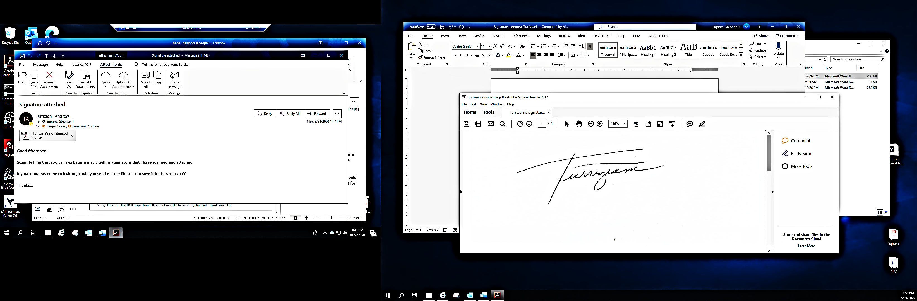

_______________________________
Andrew Turriziani, Chief of Enforcement
Bureau of Investigation and Enforcement
Motor Carrier Enforcement Division
400 North Street
Harrisburg, PA 17120

VERIFICATION

I, Andrew Turriziani, hereby state that the facts above set forth are true and correct to the best of my knowledge, information, and belief and that I expect that the Bureau will be able to prove same at any hearing held in this matter. I understand that the statements herein are made subject to the penalties of 18 Pa. C.S. §4904 relating to unsworn falsification to authorities.

Date: ___January 21, 2022____ _________________________________

Andrew Turriziani, Chief of Enforcement
Bureau of Investigation and Enforcement
Motor Carrier Enforcement Division

NOTICE

- You must file an Answer within twenty (20) days of the date of service of this Complaint. The date of service is the mailing date as indicated at the top of the Secretarial Cover Letter for this Complaint and Notice, 52 Pa. Code §1.56(a). An Answer is a written explanation of circumstances wished to be considered in determining the outcome. The Answer shall raise all factual and legal arguments that you wish to claim in your defense and must include the reference number of this Complaint. Your Answer must be verified, and the original shall be mailed to:

Rosemary Chiavetta, Secretary
Pennsylvania Public Utility Commission
400 North Street, 2nd Floor
Harrisburg, Pennsylvania 17120

Or you may eFile your Answer using the Commission’s website at www.puc.pa.gov. The link to eFiling is located under the Filing & Resources tab on the homepage. If your Answer is 250 pages or less, you are not required to file a paper copy. If your Answer exceeds 250 pages, you must file a paper copy with the Secretary’s Bureau.

Additionally, a copy should either be mailed to:

Michael L. Swindler, Deputy Chief Prosecutor
Bureau of Investigation and Enforcement
Pennsylvania Public Utility Commission
400 North Street
Harrisburg, Pennsylvania 17120

Or, e-mailed to Mr. Swindler at: RA-PCCmplntResp@pa.gov

- If you fail to answer this complaint within twenty (20) days, the Bureau of Investigation and Enforcement will request that the Commission issue a Secretarial Letter imposing a penalty. The penalty could include a fine, the suspension or revocation of your certificate of public convenience or other remedy.

- If you file an Answer, which admits or fails to deny the allegations of the Complaint, the Bureau of Investigation and Enforcement will request that the Commission issue a Secretarial Letter imposing a penalty.

- If you file an Answer which contests the Complaint, the matter will be assigned to an Administrative Law Judge for hearing and decision. The judge is not bound by the optional fine set forth above.

- Alternative formats of this material are available for persons with disabilities by contacting the Commission’s ADA Coordinator at 717-787-8714.

