 | COMMONWEALTH OF PENNSYLVANIA  PENNSYLVANIA PUBLIC UTILITY COMMISSION  400 NORTH STREET, HARRISBURG, PA 17120 | IN REPLY PLEASE REFER TO OUR FILE
February 4, 2022
Docket No.: R-2020-3020919
Utility Code: 210060

J H. RUSSELL
AUDUBON WATER COMPANY
PO BOX 7337
AUDUBON, PA 19407
jh@audubonwater.com

RE: Audubon Water Company Long-Term Infrastructure Improvement Plan Requirements at Docket No. R-2020-3020919

Dear Mr. Russell,

In its Order entered March 11, 2021, at Docket No. R-2020-3020919 (March Order), the Pennsylvania Public Utility Commission (Commission) adopted the Recommended Decision of Administrative Law Judge Darlene Davis Heep, dated February 11, 2021, approving the Joint Petition for Full Settlement of Rate Proceeding, filed on January 20, 2021 (Settlement). Settlement term 27a stated that Audubon will file a Long-Term Infrastructure Improvement Plan with the Commission pursuant to Docket No. L-2012-2317274, 66 Pa.C.S. § 1352, and 52 Pa. Code §§121.1-121.8. To assist the Commission in determining the status of Audubon’s LTIIP filing, please respond with the information requested in Attachment 1.

Please forward the information to the Secretary of the Commission within ten (10) business days from the date of this letter. All documents requiring notary stamps must have original signatures. The Commission strongly encourages submission through efiling with the Secretary of the Commission by opening an efiling account through the Commission’s website and accepting eservice at https://efiling.puc.pa.gov. The Commission is accepting all public documents through our efiling system at this time.

If your filing contains confidential material, you are required to either file by overnight delivery or submit to the Secretary’s Share Point File system to ensure the timely filing of your submission. Filers should contact the Secretary’s Bureau in advance to gain access to the Share Point File system. Make sure to reference the Docket Number listed above when filing your response. The overnight address for hard-copy or confidential responses is:

Rosemary Chiavetta, Secretary
Pennsylvania Public Utility Commission
400 North Street
Harrisburg, PA 17120
Your answers should be verified per 52 Pa Code § 1.36. Accordingly, you must provide the following statement with your responses:

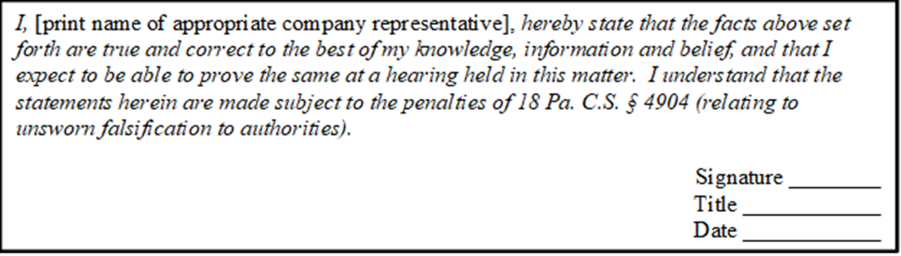

Please contact the below staff person if any problems should arise that prevent a full response within ten business days or if any clarification of these data requests is needed. Please mark the materials “CONFIDENTIAL” in bold or highlighted manner if any of the requested information is deemed to be of a confidential nature.

In addition, to expedite completion of the review, please send a copy of your response to Ken Shaffer in the Reliability and Emergency Preparedness Section of the Bureau of Technical Utility Services via e-mail at kennshaffe@pa.gov. Thank you in advance for your cooperation.

Sincerely,

Rosemary Chiavetta
Secretary

Enclosure: Attachment 1

cc: Dan Searfoorce, TUS
John Van Zant, TUS
Ken Shaffer, TUS
Patricia Wiedt, LAW

Attachment 1
TUS Data Request 1
Audubon Water Company Long-Term Infrastructure Improvement Plan Requirement
Docket No. R-2020-3020919

Note: Please restate the data request prior to providing a response. In addition, provide the name and title of the person(s) providing the response and/or information for each data request.

- Reference Joint Petition for Full Settlement of Rate Proceeding, filed on January 20, 2021
  - Please state the date Audubon Water Company will file a Long-Term Infrastructure Improvement Plan.

