BEFORE THE
PENNSYLVANIA PUBLIC UTILITY COMMISSION

PENNSYLVANIA PUBLIC UTILITY COMMISSION :
BUREAU OF INVESTIGATION AND ENFORCEMENT :
:
V. : DOCKET NO. C-2022-3028912
:
WHC PA LLC :
1301 BEAVER AVENUE :
PITTSBURGH PA 15233 :

COMPLAINT

The Pennsylvania Public Utility Commission (Commission) is a duly constituted agency of the Commonwealth of Pennsylvania empowered to regulate public utilities within the Commonwealth. The Commission has delegated its authority to initiate proceedings which are prosecutory in nature to the Bureau of Investigation and Enforcement and other bureaus with enforcement responsibilities. Pursuant to that delegated authority and Section 701 of the Public Utility Code, the Bureau of Investigation and Enforcement hereby represents as follows:

- That WHC PA LLC, Respondent, maintains its principal place of business at 1301 Beaver Avenue, Pittsburgh, Pennsylvania, 15233.

- That Respondent was issued certificates of public convenience by this Commission for taxi and limousine authority on December 3, 2019, paratransit authority on May 4, 2020, at PUC utility code no. 6322525.

- That on October 3, 2021, the Commission received a complaint alleging violations of Commission regulations occurred during a trip on that day. The individual stated he contacted the Respondent and requested to be picked up at 3:00 am on September 29, 2021 and was picked up five hours later, at 8:00 am.

- That on January 6, 2022 PUC Enforcement Officer Ryan Balestra emailed Chad Stepinak, General Manager of WHC LLC about the complaint. Officer Balestra requested trip sheet information and was provided with an electronic log.

- That Respondent, by failing to provide service at the scheduled pickup time, violated 66 Pa. CS §1501 in that it failed to furnish and maintain adequate, efficient, safe, and reasonable service. The penalty for this violation is $500.00.

WHEREFORE, the Bureau of Investigation and Enforcement hereby requests that the Commission fine WHC PA LLC the sum of five hundred dollars ($500.00) for the illegal activity described in this Complaint and order such other remedy as the Commission may deem to be appropriate.

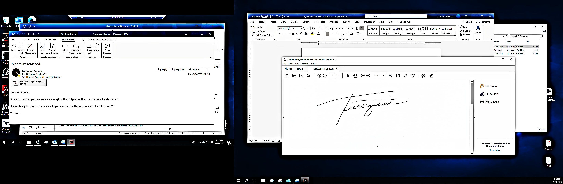
Respectfully submitted,

________________________________
Andrew Turriziani, Chief
Motor Carrier Enforcement
Bureau of Investigation and Enforcement
400 North Street
Harrisburg, PA 17120

VERIFICATION

I, Andrew Turriziani, hereby state that the facts above set forth are true and correct to the best of my knowledge, information, and belief and that I expect that the Bureau will be able to prove same at any hearing held in this matter. I understand that the statements herein are made subject to the penalties of 18 Pa. C.S. §4904 relating to unsworn falsification to authorities.

Date: ____February 2, 2022___ ____________________________
Andrew Turriziani, Chief
Motor Carrier Enforcement
Bureau of Investigation and Enforcement

NOTICE

- You must file an Answer within twenty (20) days of the date of service of this Complaint. The date of service is the mailing date as indicated at the top of the Secretarial Cover Letter for this Complaint and Notice, 52 Pa. Code §1.56(a). An Answer is a written explanation of circumstances wished to be considered in determining the outcome. The Answer shall raise all factual and legal arguments that you wish to claim in your defense and must include the reference number of this Complaint. Your Answer must be verified, and the original shall be mailed to:

Rosemary Chiavetta, Secretary
Pennsylvania Public Utility Commission
400 North Street, 2nd Floor
Harrisburg, Pennsylvania 17120

Or you may eFile your Answer using the Commission’s website at www.puc.pa.gov. The link to eFiling is located under the Filing & Resources tab on the homepage. If your Answer is 250 pages or less, you are not required to file a paper copy. If your Answer exceeds 250 pages, you must file a paper copy with the Secretary’s Bureau.

Additionally, a copy should either be mailed to:

Michael L. Swindler, Deputy Chief Prosecutor
Bureau of Investigation and Enforcement
Pennsylvania Public Utility Commission
400 North Street, 3rd Floor
Harrisburg, Pennsylvania 17120

Or, e-mailed to Mr. Swindler at: RA-PCCmplntResp@pa.gov

- If you fail to answer this complaint within twenty (20) days, the Bureau of Investigation and Enforcement will request that the Commission issue a Secretarial Letter imposing a penalty. The penalty could include a fine, the suspension or revocation of your certificate of public convenience or other remedy.

- You may elect not to contest this complaint by paying the fine proposed in this Complaint by certified check or money order. Payment must be made to the Commonwealth of Pennsylvania and should be forwarded to:

Rosemary Chiavetta, Secretary
Pennsylvania Public Utility Commission
400 North Street, 2nd Floor
Harrisburg, Pennsylvania 17120

- Your payment is an admission that you committed the alleged violation and an agreement to cease and desist from further violations. Upon receipt of your payment, the complaint proceeding shall be closed.

- If you file an Answer, which admits or fails to deny the allegations of the Complaint, the Bureau of Investigation and Enforcement will request that the Commission issue a Secretarial Letter imposing a penalty.

- If you file an Answer which contests the Complaint, the matter will be assigned to an Administrative Law Judge for hearing and decision. The judge is not bound by the optional fine set forth above.

- Alternative formats of this material are available for persons with disabilities by contacting the Commission’s ADA Coordinator at 717-787-8714.

