 | COMMONWEALTH OF PENNSYLVANIA  PENNSYLVANIA PUBLIC UTILITY COMMISSION  COMMONWEALTH KEYSTONE BUILDING  400 NORTH STREET  HARRISBURG, PENNSYLVANIA 17120 | IN REPLY PLEASE REFER TO OUR FILE

C-2022-3029073

Date of Service: February 10, 2022

TAKOUKAM TRADING LLC
t/a AMERICAN TAXI
2907 GREEN STREET
HARRISBURG PA 17110

PENNSYLVANIA PUBLIC UTILITY COMMISSION
BUREAU OF INVESTIGATON & ENFORCEMENT
v.
TAKOUKAM TRADING LLC t/a AMERICAN TAXI

Dear Sir/Madam:

Please be advised that the attached complaint has been filed against you by the Bureau of Investigation & Enforcement.

Detailed instructions on how to proceed are contained in the NOTICE section, and you are advised to read everything carefully or consult with your attorney.

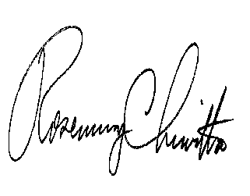
Very truly yours,

Rosemary Chiavetta
Secretary

Attachments

NW

