 | COMMONWEALTH OF PENNSYLVANIA  PENNSYLVANIA PUBLIC UTILITY COMMISSION  COMMONWEALTH KEYSTONE BUILDING  400 NORTH STREET  HARRISBURG, PENNSYLVANIA 17120 | IN REPLY PLEASE REFER TO OUR FILE

C-2022-3029079
Date of Service: February 14, 2022

GOOD CAB LLC
2304 WALNUT STREET
HARRISBURG PA 17103

PENNSYLVANIA PUBLIC UTILITY COMMISSION
BUREAU OF INVESTIGATON & ENFORCEMENT
v.
GOOD CAB LLC

Dear Sir/Madam:

Please be advised that the attached complaint has been filed against you by the Bureau of Investigation & Enforcement.

Detailed instructions on how to proceed are contained in the NOTICE section, and you are advised to read everything carefully or consult with your attorney.

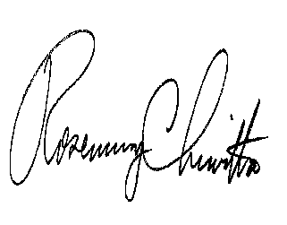
Very truly yours,

Rosemary Chiavetta
Secretary

Attachments

NW

