 | COMMONWEALTH OF PENNSYLVANIA  PENNSYLVANIA PUBLIC UTILITY COMMISSION  COMMONWEALTH KEYSTONE BUILDING  400 NORTH STREET  HARRISBURG, PENNSYLVANIA 17120 | IN REPLY PLEASE REFER TO OUR FILE

C-2022-3023215
Date of Service: February 15, 2022

JIMS LAWN MAINTENANCE & EXCAVATING LLC
JIM BURKEY
1037 MOUNTAINVIEW DRIVE
QUAKERTOWN, PA 18951

PENNSYLVANIA PUBLIC UTILITY COMMISSION
BUREAU OF INVESTIGATON & ENFORCEMENT
v.
JIMS LAWN MAINTENANCE & EXCAVATING LLC

Dear Sir/Madam:

Please be advised that the attached complaint has been filed against you by the Bureau of Investigation & Enforcement.

Detailed instructions on how to proceed are contained in the NOTICE section, and you are advised to read everything carefully or consult with your attorney.

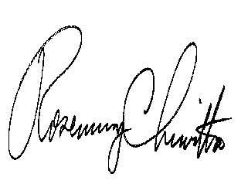
Very truly yours,

Rosemary Chiavetta
Secretary

Attachments

NW

