BEFORE THE
PENNSYLVANIA PUBLIC UTILITY COMMISSION

PENNSYLVANIA PUBLIC UTILITY COMMISSION :
BUREAU OF INVESTIGATION AND ENFORCEMENT :
:
v. : DOCKET NO. C-2022-3029076
:
EXTREME HEALTH CARE SERVICES LLC :
2011 CLAYTON AVENUE :
HARRISBURG PA 17109 :

COMPLAINT

The Pennsylvania Public Utility Commission (Commission) is a duly constituted agency of the Commonwealth of Pennsylvania empowered to regulate public utilities within the Commonwealth. The Commission has delegated its authority to initiate proceedings which are prosecutory in nature to the Bureau of Investigation and Enforcement and other bureaus with enforcement responsibilities. Pursuant to that delegated authority and Section 701 of the Public Utility Code, the Bureau of Investigation and Enforcement hereby represents as follows:

That EXTREME HEALTH CARE SERVICES LLC, Respondent, maintains its principal place of business at 320 Muench Street, Harrisburg, Pennsylvania, 17103 and a mailing address of 2011 Clayton Avenue Harrisburg, Pennsylvania, 17109.

- That Respondent was issued a certificate of public convenience authorizing paratransit authority on November 26, 2013, at Pa. PUC utility code no. 6415315.

- That on October 5 – 7, 2021, PUC Motor Carrier Enforcement Officers
Steven Watkins and Neal Ebbert, conducted an inspection of driver vehicles and records at Respondent’s principal office at 320 Muench Street, Harrisburg, Dauphin County, Pa.

- That Respondent operates a 2008 Ford with Pa. license No. BA80860 and Vehicle Identification Number 1FMCU94128KB34352. The following violations were found:

- The right front tire was worn to a measured 1/32 of an inch.
- The vehicle battery was not securely fastened.

- That Respondent permitted two (2) employees to transport passengers without first obtaining and reviewing a driver history report.

- That Respondent permitted five (5) employees to transport passengers without first obtaining and reviewing a criminal history report.

- That Respondent, by permitting a vehicle to be operated with tires that have less than the required tread depth, violated 52 Pa. Code §29.402(1) and 67 Pa. Code §175.65(a). The penalty for this violation is $100.00.

- That Respondent, by permitting a vehicle to be operated with a vehicle battery that was not securely fastened, violated 52 Pa. Code §29.402(1) and 67 Pa. Code §175.66(n). The penalty for this violation is $100.00.

- That Respondent, by permitting persons to provide transport services before obtaining and reviewing the drivers’ history reports, violated 52 Pa. Code § 29.504(b)(1). The penalty for these violations is $100.00 per violation. The total fine is $200.00.

- That Respondent, by permitting drivers to operate vehicles in paratransit services before obtaining and reviewing the criminal histories, violated 52 Pa. Code §29.505(b)(1). The penalty for this violation is $250.00 per violation. The total fine is $1,250.00.

WHEREFORE, the Bureau of Investigation and Enforcement hereby requests that the Commission fine EXTREME HEALTH CARE SERVICES LLC the sum of one thousand six hundred and fifty dollars ($1,650.00) for the illegal activity described in this Complaint and order such other remedy as the Commission may deem to be appropriate.

Respectfully submitted,
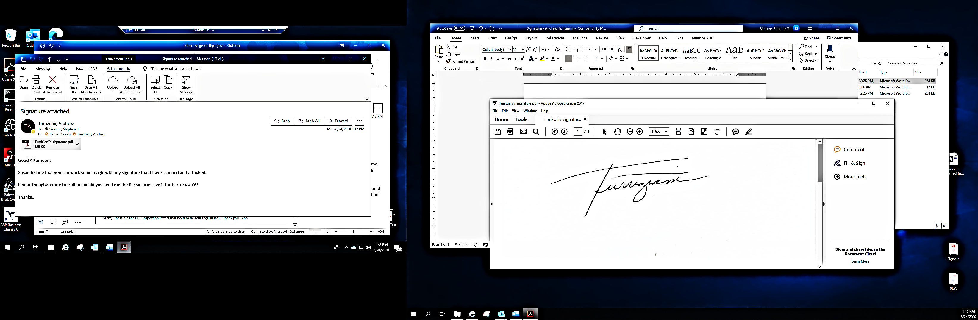

________________________________
Andrew Turriziani, Chief
Bureau of Investigation and Enforcement
Motor Carrier Enforcement Division
400 North Street
Harrisburg, PA 17120

VERIFICATION

I, Andrew Turriziani, hereby state that the facts above set forth are true and correct to the best of my knowledge, information and belief and that I expect that the Bureau will be able to prove same at any hearing held in this matter. I understand that the statements herein are made subject to the penalties of 18 Pa. C.S. §4904 relating to unsworn falsification to authorities.

Date: February 14, 2022 _________________________________
Andrew Turriziani, Chief
Motor Carrier Enforcement
Bureau of Investigation and Enforcement

NOTICE

- You must file an Answer within twenty (20) days of the date of service of this Complaint. The date of service is the mailing date as indicated at the top of the Secretarial Cover Letter for this Complaint and Notice, 52 Pa. Code §1.56(a). An Answer is a written explanation of circumstances wished to be considered in determining the outcome. The Answer shall raise all factual and legal arguments that you wish to claim in your defense and must include the reference number of this Complaint. Your Answer must be verified, and the original shall be mailed to:

Rosemary Chiavetta, Secretary
Pennsylvania Public Utility Commission
400 North Street, 2nd Floor
Harrisburg, Pennsylvania 17120

Or you may eFile your Answer using the Commission’s website at www.puc.pa.gov. The link to eFiling is located under the Filing & Resources tab on the homepage. If your Answer is 250 pages or less, you are not required to file a paper copy. If your Answer exceeds 250 pages, you must file a paper copy with the Secretary’s Bureau.

Additionally, a copy should either be mailed to:

Michael L. Swindler, Deputy Chief Prosecutor
Pennsylvania Public Utility Commission
Bureau of Investigation and Enforcement
400 North Street
Harrisburg, PA 17120

Or, e-mailed to Mr. Swindler at: RA-PCCmplntResp@pa.gov

- If you fail to answer this complaint within twenty (20) days, the Bureau of Investigation and Enforcement will request that the Commission issue a Secretarial Letter imposing a penalty. The penalty could include a fine, the suspension or revocation of your certificate of public convenience or other remedy.

- You may elect not to contest this complaint by paying the fine proposed in this Complaint by certified check or money order. Payment must be made to the Commonwealth of Pennsylvania and should be forwarded to:

Rosemary Chiavetta, Secretary
Pennsylvania Public Utility Commission
400 North Street
Harrisburg, PA 17120

- Your payment is an admission that you committed the alleged violation and an agreement to cease and desist from further violations. Upon receipt of your payment, the complaint proceeding shall be closed.

- If you file an Answer, which admits or fails to deny the allegations of the Complaint, the Bureau of Investigation and Enforcement will request that the Commission issue a Secretarial Letter imposing a penalty.

- If you file an Answer which contests the Complaint, the matter will be assigned to an Administrative Law Judge for hearing and decision. The judge is not bound by the optional fine set forth above.

- Alternative formats of this material are available for persons with disabilities by contacting the Commission’s ADA Coordinator at 717-787-8714.

