BEFORE THE
PENNSYLVANIA PUBLIC UTILITY COMMISSION

PENNSYLVANIA PUBLIC UTILITY COMMISSION :
BUREAU OF INVESTIGATION AND ENFORCEMENT :
:
v. : DOCKET# C-2022-3029080
:
KEYSTONE CAB SERVICE INC :
2304 A WALNUT STREET :
HARRISBURG PA 17103 :

COMPLAINT

The Pennsylvania Public Utility Commission (Commission) is a duly constituted agency of the Commonwealth of Pennsylvania empowered to regulate public utilities within the Commonwealth. The Commission has delegated its authority to initiate proceedings which are prosecutory in nature to the Bureau of Investigation and Enforcement and other bureaus with enforcement responsibilities. Pursuant to that delegated authority and Section 701 of the Public Utility Code, the Bureau of Investigation and Enforcement hereby represents as follows:

- That KEYSTONE CAB SERVICE INC, Respondent, maintains its principal place of business at 620 South 13th Street, Harrisburg, Pennsylvania, 17104 and has a mailing address of 2304 A Walnut Street Harrisburg, Pennsylvania 17103.

- That Respondent was issued a certificate of public convenience by this Commission authorizing transportation of passengers under taxi authority on July 15, 2002 at Pa. PUC utility code no. 632090.

- That on October 6, 2021, PUC Motor Carrier Enforcement Officers Elliot Miller, Travis Griffith, and Barry Pacovsky arrived at Respondent’s principal business of 620 South 13th Street, Harrisburg, Dauphin County, Pennsylvania 17104, to perform an inspection of the company’s vehicles and driver records.

- That on October 6, 2021, Officer Miller inspected a certain 2011 Chevrolet bearing Pa. license number TX50299 and having Vehicle Identification No. 3GNBABFWOBS559354
to be operated. The following violation was found:
- Dome light on vehicle was inoperable and therefore, incapable of being illuminated.

5. That Respondent, by permitting a vehicle to be operated that did not have a dome light affixed to roof, violated 52 Pa. Code § 29.314(d). The penalty for this violation is $100.00.

WHEREFORE, the Bureau of Investigation and Enforcement hereby requests that the Commission fine Keystone Cab Service Inc the sum of two hundred and fifty dollars ($100.00) for the illegal activity described in this Complaint and order such other remedy as the Commission may deem to be appropriate.
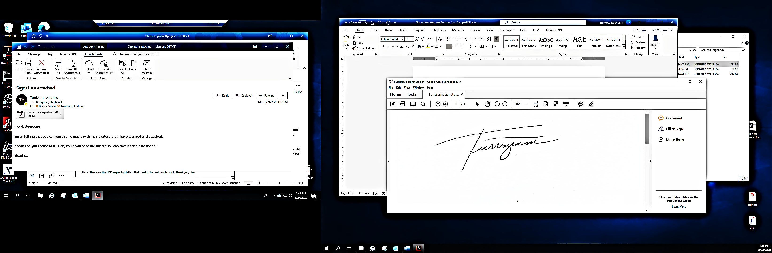
Respectfully submitted,

________________________________
Andrew Turriziani, Chief
Bureau of Investigation and Enforcement
Motor Carrier Enforcement Division
400 North Street
Harrisburg, PA 17120

VERIFICATION

I, Andrew Turriziani, hereby state that the facts above set forth are true and correct to the best of my knowledge, information, and belief and that I expect that the Bureau will be able to prove same at any hearing held in this matter. I understand that the statements herein are made subject to the penalties of 18 Pa. C.S. §4904 relating to unsworn falsification to authorities.

Date: February 15, 2022 _________________________________
Andrew Turriziani, Chief
Motor Carrier Enforcement
Bureau of Investigation and Enforcement

NOTICE

- You must file an Answer within twenty (20) days of the date of service of this Complaint. The date of service is the mailing date as indicated at the top of the Secretarial Cover Letter for this Complaint and Notice, 52 Pa. Code §1.56(a). An Answer is a written explanation of circumstances wished to be considered in determining the outcome. The Answer shall raise all factual and legal arguments that you wish to claim in your defense and must include the reference number of this Complaint. Your Answer must be verified, and the original shall be mailed to:

Rosemary Chiavetta, Secretary
Pennsylvania Public Utility Commission
400 North Street, 2nd Floor
Harrisburg, Pennsylvania 17120

Or you may eFile your Answer using the Commission’s website at www.puc.pa.gov. The link to eFiling is located under the Filing & Resources tab on the homepage. If your Answer is 250 pages or less, you are not required to file a paper copy. If your Answer exceeds 250 pages, you must file a paper copy with the Secretary’s Bureau.

Additionally, a copy should either be mailed to:

Michael L. Swindler, Deputy Chief Prosecutor
Pennsylvania Public Utility Commission
Bureau of Investigation and Enforcement
400 North Street
Harrisburg, PA 17120

Or, e-mailed to Mr. Swindler at: RA-PCCmplntResp@pa.gov

- If you fail to answer this complaint within twenty (20) days, the Bureau of Investigation and Enforcement will request that the Commission issue a Secretarial Letter imposing a penalty. The penalty could include a fine, the suspension or revocation of your certificate of public convenience or other remedy.

- You may elect not to contest this complaint by paying the fine proposed in this Complaint by certified check or money order. Payment must be made to the Commonwealth of Pennsylvania and should be forwarded to:

Rosemary Chiavetta, Secretary
Pennsylvania Public Utility Commission
400 North Street
Harrisburg, PA 17120

- Your payment is an admission that you committed the alleged violation and an agreement to cease and desist from further violations. Upon receipt of your payment, the complaint proceeding shall be closed.

- If you file an Answer, which admits or fails to deny the allegations of the Complaint, the Bureau of Investigation and Enforcement will request that the Commission issue a Secretarial Letter imposing a penalty.

- If you file an Answer which contests the Complaint, the matter will be assigned to an Administrative Law Judge for hearing and decision. The judge is not bound by the optional fine set forth above.

- Alternative formats of this material are available for persons with disabilities by contacting the Commission’s ADA Coordinator at 717-787-8714.

