COMMONWEALTH OF PENNSYLVANIA
PENNSYLVANIA PUBLIC UTILITY COMMISSION _{IN REPLY PLEASE}
400 North Street, HARRISBURG, PA 17120 ^{REFER TO OUR FILE}

February 22, 2022

Per the Waiver of Regulations Regarding Service Requirements
at M-2020-3019262, service is being made by electronic means only

ALL PARTIES OF RECORD

RE: Donald Osinski vs. Aqua Pennsylvania Wastewater Inc

Docket Number: C-2021-3029413

To All Parties of Record:

On February 21, 2022, my office received Exceptions to the Initial Decision of
Administrative Law Judge Mary D. Long in the above captioned matter.

Our review of the filing revealed that no Certificate of Service or other indication that the Parties of Record to the case were served with the Exceptions. Therefore, we have attached a copy of the Exceptions to constitute service for purposes of 52 Pa. Code §5.533.

Sincerely,
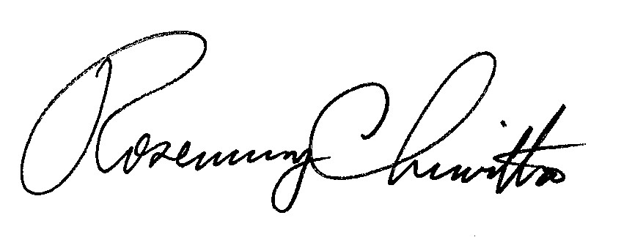
Rosemary Chiavetta

Secretary

Attachment: Exceptions of Donald Osinski

RC: JAV

cc: All Parties of Record
Document Folder

