PENNSYLVANIA
PUBLIC UTILITY COMMISSION
Harrisburg, PA 17120

Public Meeting held February 24, 2022

Commissioners Present:

Gladys Brown Dutrieuille, Chairman
John F. Coleman, Jr., Vice Chairman
Ralph V. Yanora

Application of CSX Transportation, Inc. A-2019-3013783
for Approval of the Abolition of the Crossing
(DOT 140 634 G) where Cemetery Avenue
crosses above grade the tracks of CSX Transportation,
Inc. located in the City of Philadelphia, Philadelphia
County, and the allocation of cost thereto

OPINION AND ORDER

BY THE COMMISSION:

Before the Pennsylvania Public Utility Commission (Commission) for consideration and disposition is the Petition for Reconsideration (Petition) filed by CSX Transportation, Inc. (CSXT) on February 18, 2022, seeking reconsideration of the Opinion and Order entered on February 3, 2022, relative to the above-captioned proceeding.

Pursuant to Rule 1701 of the Pennsylvania Rules of Appellate Procedure, Pa. R.A.P. 1701, the Commission must act to grant a petition for reconsideration within thirty days of the date of entry of the order for which reconsideration is sought or otherwise lose jurisdiction to do so if a petition for review is timely filed. The thirty-day period within which the Commission must act upon the Petition in order to preserve jurisdiction ends on March 7, 2022.

Granting reconsideration pending review of, and consideration on, the merits of the Petition to preserve Commission jurisdiction and toll the thirty-day time period for filing a petition for appellate review does not automatically stay the Commission’s underlying Opinion and Order. Pursuant to 52 Pa. Code § 5.572, petitions seeking a stay or supersedeas must be filed with the Commission within 15 days after the underlying Opinion and Order becomes final.

Accordingly, we shall grant reconsideration, within the meaning of Pa. R.A.P. 1701(b)(3), pending review of, and consideration on, the merits of the Petition; THEREFORE,

IT IS ORDERED: That the Petition for Reconsideration filed by CSX Transportation, Inc. (CSXT) on February 18, 2022, is hereby granted, pending further review of, and consideration on, the merits.

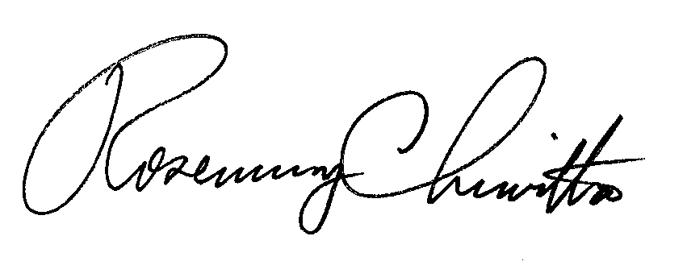
BY THE COMMISSION,

Rosemary Chiavetta
Secretary

(SEAL)

ORDER ADOPTED: February 24, 2022

ORDER ENTERED: February 24, 2022

Commission Rules of Practice and Procedure provide that a party may file an Answer to the Petition within ten (10) days of service. 52 Pa. Code § 5.571(c). As of the date of this Order no Answers have been received.
The thirty-day period ends on March 5, 2022, which is a Saturday. Therefore, the next business day, March 7, 2022, is the deadline for the Commission to act on the Petition.
52 Pa. Code § 5.572; Pa. R.A.P. 1701.
See also Pa. R.A.P. 1781.

