 | COMMONWEALTH OF PENNSYLVANIA  PENNSYLVANIA PUBLIC UTILITY COMMISSION  COMMONWEALTH KEYSTONE BUILDING  400 NORTH STREET  HARRISBURG, PENNSYLVANIA 17120 | IN REPLY PLEASE REFER TO OUR FILE

February 28, 2022
A-2021-3024681

Application of Pennsylvania-American Water Company under Section 1102(a) of the Pennsylvania Public Utility Code, 66 Pa C.S. § 1102(a), for approval of (1) the transfer, by sale, to Pennsylvania-American Water Company, of substantially all of the assets, properties and rights related to the wastewater collection and treatment system owned by the York City Sewer Authority and operated by the City of York, (2) the rights of Pennsylvania-American Water Company to begin to offer or furnish wastewater service to the public in the City of York, Pennsylvania, and to three bulk service interconnection points located in North York Borough, Manchester Township and York Township, York County, Pennsylvania, and (3) the rights of Pennsylvania-American Water Company to begin to offer and furnish Industrial Pretreatment Program to qualifying industrial customers in Manchester Township, Spring Garden Township and West Manchester Township, York County, Pennsylvania.

TO ALL PARTIES:

Enclosed is a copy of the Recommended Decision of the Office of Administrative Law Judge.

If you do not agree with any part of this decision, you may send written comments (called Exceptions) to the Commission. Your signed Exceptions to the decision, if any, must be: 1) filed with the Secretary of the Commission, and 2) to each party of record. Your Exceptions are due by 4:30 p.m. on March 7, 2022.

Exceptions must be efiled with the Secretary of the Commission by opening an efiling account through the Commission’s website and accepting eservice at http://www.puc.state.pa.us/efiling/default.aspx. If your filing contains confidential material, you are required to file by overnight delivery to ensure the timely filing of your submission.

In addition to filing with the Secretary of the Commission, a courtesy copy of your Exceptions must be emailed to the Commission’s Office of Special Assistants (OSA) at ra-OSA@pa.gov. Your filing should not be larger than 10mb.

Replies to Exceptions will not be accepted and will not be entertained by the Commission.

It is your responsibility to serve all the parties with your Exceptions. Failure to do so may render your filing unacceptable. A certificate of service (see format in 52 Pa. Code §1.58) shall be attached to the filed Exceptions.

Exceptions shall follow 52 Pa. Code §§5.533 and 5.535 particularly the 40-page limit for Exceptions and the 25-page limit for Replies to Exceptions. Exceptions should clearly be labeled as "EXCEPTIONS OF (name of party) - (protestant, complainant, staff, etc.)". Any reference to specific sections of the Administrative Law Judge’s Decision shall include the page number(s) of the cited section of the decision.

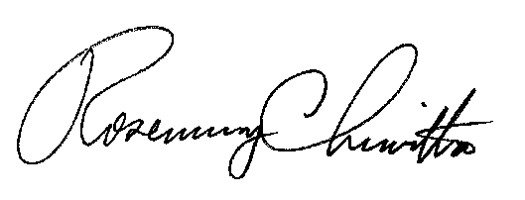
Sincerely,

Rosemary Chiavetta
Secretary
Decision attached

