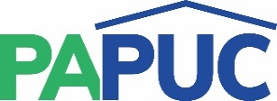 | COMMONWEALTH OF PENNSYLVANIA  PENNSYLVANIA PUBLIC UTILITY COMMISSION  COMMONWEALTH KEYSTONE BUILDING  400 NORTH STREET  HARRISBURG, PENNSYLVANIA 17120 | IN REPLY PLEASE REFER TO OUR FILE

March 3, 2022

RACHEL ADAMS, ACCOUNT MANAGER
LICENSELOGIX
140 GRAND ST, SUITE 300
WHITE PLAINS, NY 10601
Email: RAdams@LicenseLogix.com

Dear Ms. Adams:

On March 3, 2022, the Commission received your E-filed Application of United Power Consultants, Inc. for approval to supply Natural Gas Services to the public in the Commonwealth of PA. Upon initial review, the Application has been determined to be deficient for the following reasons:
1.Application is filled out on an old template. Application form must have revised date of 12/29/21. Here is the link to new NGS Application form (also Attached) .
NGS_Lic_App-122921.pdf (pa.gov)
You may fill out the latest Application form & e-file it as an Application Update/ Revision with a notation that it goes with the E-filing confirmation number (2371655)of the initial filing.
2. Tax certification Statement must be submitted – Have you mailed us the Tax certification Statement?
Pursuant to 52 Pa. Code §1.4, you are being advised of these deficiencies and are required to file corrections. Failure to correct the foregoing deficiencies within 20 days of the date of this letter will result in the Application being returned unfiled.
Please return your items to the above listed address and address to the attention of the Office of the Secretary.
If you have any question in regards to this letter, please contact our bureau at (717) 772-7777. Thank you
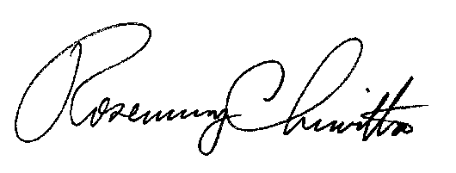
Sincerely,

Rosemary Chiavetta
Secretary
RC:jbs

