
COMMONWEALTH OF PENNSYLVANIA
PENNSYLVANIA PUBLIC UTILITY COMMISSION _{IN REPLY PLEASE}
400 North Street, HARRISBURG, PA 17120 ^{REFER TO OUR FILE}

April 8, 2022

Per the Waiver of Regulations Regarding Service Requirements
at M-2020-3019262, service is being made by electronic means only

ALL PARTIES OF RECORD

RE: Patricia Wasserman vs. PPL Electric Utilities Corporation

Docket Number: F-2021-3027092

To All Parties of Record:

On April 8, 2022, my office received Exceptions to the Initial Decision of
Administrative Law Judge Darlene Heep in the above captioned matter.

Our review of the filing revealed that no Certificate of Service or other indication that the Parties of Record to the case were served with the Exceptions. Therefore, we have attached a copy of the Exceptions to constitute service for purposes of 52 Pa. Code §5.533.

Sincerely,
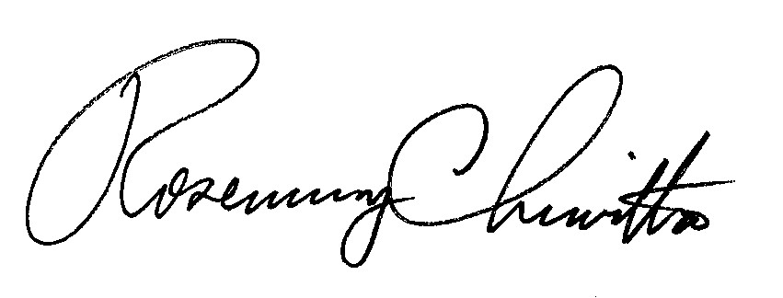
Rosemary Chiavetta

Secretary

Attachment: Exceptions of Patricia Wasserman

RC: JAV

cc: All Parties of Record
Document Folder

