
COMMONWEALTH OF PENNSYLVANIA
PENNSYLVANIA PUBLIC UTILITY COMMISSION _{IN REPLY PLEASE}
400 North Street, HARRISBURG, PA 17120 ^{REFER TO OUR FILE}

April 19, 2022

Per the Waiver of Regulations Regarding Service Requirements
at M-2020-3019262, service is being made by electronic means only

ALL PARTIES OF RECORD

RE: Amanda Herr vs. West Penn Power (FirstEnergy)

Docket Number: C-2021-3028202

To All Parties of Record:

On April 8, 2022, my office received Exceptions to the Initial Decision of
Administrative Law Judge Mary D. Long in the above captioned matter.

Our review of the filing revealed that no Certificate of Service or other indication that the Parties of Record to the case were served with the Exceptions. Therefore, we have attached a copy of the Exceptions to constitute service for purposes of 52 Pa. Code §5.533.
Due to the failure of Amanda Herr to provide service on all the parties of record to the case, and in order to avoid prejudice to any party pursuant to 52 Pa. Code 5.535, the Respondent shall have until Friday, April 29, 2022 to file Reply Exceptions.

Sincerely,
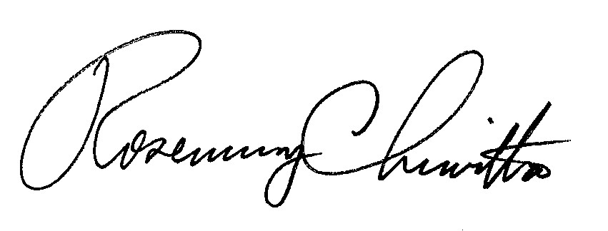
Rosemary Chiavetta

Secretary

Attachment: Exceptions of Amanda Herr

RC: JAV

cc: All Parties of Record
Document Folder

