 | COMMONWEALTH OF PENNSYLVANIA  PENNSYLVANIA PUBLIC UTILITY COMMISSION  COMMONWEALTH KEYSTONE BUILDING  400 NORTH STREET  HARRISBURG, PENNSYLVANIA 17120 | IN REPLY PLEASE REFER TO OUR FILE

April 25, 2022

ALEKSANDER DEBESAY, OWNER
ALL TRANSPORTATION LLC
7144 GUYER AVENUE
PHILADELPHIA, PA 19153
Email: intotollc@gmail.com

Dear Sir:

On April 21, 2022, the Commission received your Application for Motor Common Carrier of Persons in Paratransit Service from All Transportation LLC. Upon initial review, the Application is missing the following item needed in order to accept it as a filing.

- Your application form that is listed as revised on June 30, 2019, is now considered as outdated. Please complete and file the enclosed updated Application for Motor Common Carrier of Persons in Paratransit Service.
Pursuant to 52 Pa. Code §1.4, you are required to correct this item. Failure to do so within 20 days of the date of this letter will result in the Application being returned unfiled.

Should you have any questions pertaining to your Application, please contact our Bureau at 717-772-7777.

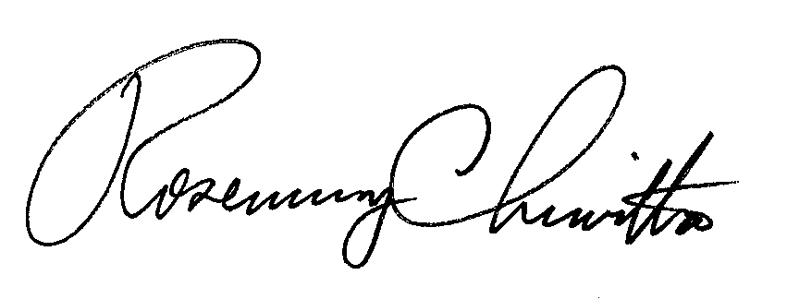
Sincerely,

Rosemary Chiavetta
Secretary

RC:AEL

Enclosure

