 | COMMONWEALTH OF PENNSYLVANIA  PENNSYLVANIA PUBLIC UTILITY COMMISSION  COMMONWEALTH KEYSTONE BUILDING  400 NORTH STREET  HARRISBURG, PENNSYLVANIA 17120 | IN REPLY PLEASE REFER TO OUR FILE

Formal Complaint Docket #: C-2022-3032485

May 17, 2022

Via e-mail only due to Emergency Order at M-2020-3019262

SUSAN SIMMS MARSH, DEPUTY GENERAL COUNSEL
PENNSYLVANIA-AMERICAN WATER COMPANY
852 WESLEY DRIVE
MECHANICSBURG, PA 17055
Email: susan.marsh@amwater.com

RE: PA PUC vs PENNSYLVANIA AMERICAN WATER COMPANY
Rate Case Docket #: R-2022-3031672

Dear Madam,

A Formal Complaint has been filed against Pennsylvania American Water Company in the above-captioned matter before the Pennsylvania Public Utility Commission by the Office of Consumer Advocate.

This true and correct copy of the complaint has been filed of record with the Pennsylvania Public Utility Commission. Both the Pennsylvania Public Utility Code, 66 Pa. C.S. and the Commission’s regulations at 52 Pa. Code Section 1.53, requires the Commission to serve on each party named in a Formal Complaint a copy of the complaint.

Within ten (10) days from the above date of service, you may either satisfy or answer this complaint in accordance with the provisions of 52 Pa Code, §5.61(d).

When filing your answer to the Formal Complaint, please reference the “Formal Complaint Docket Number” located in the upper-right hand corner of this Notice.

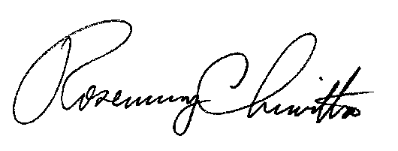
Very Truly Yours,

Rosemary Chiavetta
Secretary

RC:mm
(SEAL)

VIA EMAIL DUE TO EMERGENCY ORDER AT M-2020-3019262

