 | COMMONWEALTH OF PENNSYLVANIA  PENNSYLVANIA PUBLIC UTILITY COMMISSION  COMMONWEALTH KEYSTONE BUILDING  400 NORTH STREET  HARRISBURG, PENNSYLVANIA 17120 | IN REPLY PLEASE REFER TO OUR FILE

May 31, 2022
C-2022-3030530

Tori L. Giesler
FirstEnergy Service Company
2800 Pottsville Pike
Reading PA 19605

Margaret Morris
Reger Rizzo & Darnall
Cira Centre 13th Floor
2929 Arch Street
Philadelphia PA 19104

Gregory Bair
v.
Metropolitan Edison Company and Mid-Atlantic Interstate Transmission LLC

Dear Sir/Madam:

Attached is a copy of an amended complaint filed on behalf of the complainant in the above titled proceeding.

Such answer as you desire to make to the amended complaint should be filed in this Office and served upon the complainant within twenty days from receipt of this letter.

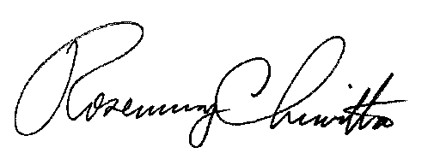
Very truly yours,

Rosemary Chiavetta
Secretary

cc: File

RC:alw

