BEFORE THE
PENNSYLVANIA PUBLIC UTILITY COMMISSION

Wuxin Yang :
: C-2022-3030596
v. :
:
Peoples Gas Company LLC :

FIRST INTERIM ORDER
DIRECTING PARTIES TO FILE A MEMORANDUM
IN SUPPORT OF THEIR POSITION

AND NOW, (1) the evidentiary hearing in this proceeding have been held on April 20, 2022; (2) the Parties having been directed at the evidentiary hearing to file a memorandum in support of their respective position in this proceeding by June 17, 2022 (Hearing Transcript pp. 92-93); (3) the hearing transcript having been filed with the Secretary’s Bureau on May 26, 2022; and (4) neither Party having filed a memorandum as of the date of this order,

THEREFORE,

IT IS ORDERED:

- That each Party shall electronically file with the Commission’s Secretary Bureau by July 22, 2022, a memorandum in support of their respective position on the issues in this proceeding, by referencing support for their position in the transcript, citing the evidence of record relied upon, referencing applicable law, and stating the relief or remedy requested from the Commission.

- That each Party shall provide an electronic copy of their memorandum to

the opposing Party and to the undersigned presiding officer’s legal assistant, Nicholas Miskanic, by July 22, 2022. The legal assistant’s email address is nmiskanic@pa.gov.

- That any memorandum filed by a Party after July 22, 2022, shall not be accepted by the undersigned presiding officer.
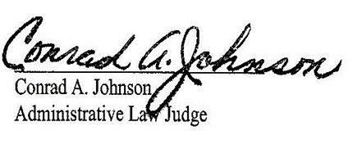

Date: June 22, 2022

C-2022-3030596 - WUXIN YANG V. PEOPLES GAS COMPANY LLC
WUXIN YANG
1014 MIRROR ST
PITTSBURGH PA 15217
412.961.5905
YANGWUXIN413@GMAIL.COM
JENNIFER PETRISEK ESQUIRE
PEOPLES GAS COMPANY LLC
375 NORTH SHORE DRIVE
PITTSBURGH PA 15212
412.208.6834
Accepts eService

